Unequal Impact of Lethal Heatwaves in India for Males
and Females: Insights from Climate Projection Data

Aanchala Bhongade*
* Visiting Researcher, Cambridge Collective Intelligence & Design Group, (Undergrad at VJTI, Mumbai)
Under the supervision of Dr. Ramit Debnath, University of Cambridge, UK

Keywords
Heatwaves, Cooling Energy Demand, Heat Index, Climate Projections, Gender-Based Vulnerabilities, Cooling Degree Days, India, SSPs (Shared Socioeconomic Pathways)

Abstract
As climate change accelerates, extreme heatwaves pose increasing risks in India, with differential impacts across gender and age groups. Using data from the World Bank Climate Knowledge Portal and CMIP6 models, we obtained time-series data for relative humidity and mean surface air temperature (1990–2100) across SSPs (1-1.9 to 5-8.5) and calculated the heat index using the Rothfusz (1990) formula, incorporating uncertainty bounds from median, 10th, and 90th percentiles.¹ Heat index maps visualised variations across SSPs. Cooling energy demand was estimated using population projections (2020–2100) for males and females, alongside historical sales data for ceiling fans and air conditioners, weighted by energy consumption factors.² Contour plots showed the relationship between heat index, energy consumption, and age-wise gender differences, showing that cooling energy demand increases with age and higher heat index values. Scatter plots revealed heat index fluctuations driving energy demand, while correlation plots linked Cooling Degree Days (CDD) to gender-based variations. Gender disparities in cooling demand are primarily socioeconomic, reflecting differential access to cooling technologies rather than physiological differences.³ These findings highlight the unequal impact of heatwaves, especially on the elderly, and can inform India’s Cooling Action Plan by prioritising subsidies for vulnerable populations to enhance resilience. Clarifying these disparities supports nuanced climate adaptation strategies addressing rising energy needs and vulnerabilities associated with extreme heat.
References
¹ Rothfusz, L. P. “The Heat Index Equation.” National Weather Service Technical Report, 1990.
² Bureau of Energy Efficiency. BEE Final Report. Ministry of Power, Government of India, n.d.
³ Gagnon, D., and Glen P. Kenny. “Sex Differences in Thermoregulatory Responses during Heat Stress.” European Journal of Applied Physiology, vol. 112, no. 9, 2012, pp. 3325–3334.

Introduction
Rising temperatures and humidity levels brought on by climate change have made heat stress in India much worse; these factors are well-represented by the heat index (HI).¹ A key indication of perceived heat stress and its effects on human health and energy systems is the heat index, which is a combination of temperature and relative humidity. As temperatures continue to rise, the frequency and intensity of heatwaves are projected to increase in India, particularly under high-emission scenarios such as the Shared Socioeconomic Pathways (SSPs). The SSPs are a set of scenarios developed to explore how global society, demographics, and economics might evolve over the 21st century, influencing greenhouse gas emissions and climate change outcomes.⁴ These pathways describe five distinct futures - SSP1 (Sustainability), SSP2 (Middle of the Road), SSP3 (Regional Rivalry), SSP4 (Inequality), and SSP5 (Fossil-fueled Development), each representing different socioeconomic trajectories and their implications for climate mitigation and adaptation challenges.⁴ For instance, SSP1-1.9 envisions a sustainable world with low emissions, while SSP5-8.5 projects a fossil-fuel-intensive future with high emissions.
The escalating heat stress has profound implications for energy demand in India, particularly for cooling, as populations seek to mitigate heat-related risks. Cooling energy demand, primarily driven by the use of air conditioners (ACs) and fans, is expected to increase in the coming decades, placing significant pressure on energy infrastructure.² This study addresses the research question: How do heat index variations across SSPs influence cooling energy demand in India, and what are the age- and gender-specific disparities in these impacts? This research fills a vital gap by analyzing age and gender disaggregated population data in the Indian setting, where demographic dynamics are understudied, in contrast to previous studies that concentrate on aggregate cooling demand or global trends.⁵ For instance, global models often overlook India’s aging population and gender-based socioeconomic disparities, which are crucial for equitable adaptation planning.⁶
Age plays a crucial role in determining heat vulnerability and energy use patterns in India, yet gender-based differences in cooling needs remain underexplored due to socioeconomic factors like access to cooling technologies.³ Older populations are generally more susceptible to heat stress due to physiological limitations, which may lead to higher cooling energy demand to maintain thermal comfort.⁷ Rising cooling demand exacerbates energy poverty and challenges grid reliability, undermining the India Cooling Action Plan’s aim to double energy-efficient cooling by 2030.⁸ This study investigates the relationship between heat index and cooling energy demand in India, weighted by age and gender distributions, across SSP1-1.9 to SSP5-8.5 from 2020 to 2099, providing insights for equitable climate adaptation and energy planning.
By combining climate projection data with cooling energy consumption estimates, this study offers a nuanced understanding of how heat stress drives cooling needs across India’s diverse population.⁹ While prior research has quantified cooling demand at national or regional levels, it often neglects how age and gender shape vulnerability and adaptation capacity in India, a gap this analysis addresses through detailed demographic weighting.¹⁰ The findings aim to support the India Cooling Action Plan by identifying priority groups, such as the elderly, for targeted cooling need to mitigate energy poverty.⁸ This approach not only clarifies the unequal impacts of heatwaves but also informs sustainable energy policies for a warming climate.
References
⁴ Riahi, Keywan, et al. “The Shared Socioeconomic Pathways and Their Energy, Land Use, and Greenhouse Gas Emissions Implications.” Global Environmental Change, vol. 42, 2017, pp. 153–168.
⁵ Mastrucci, Alessandro, et al. “Modeling Global Residential Cooling Demand under Climate Change.” Energy and Buildings, vol. 199, 2019, pp. 186–203.
⁶ Isaac, Morna, and Detlef P. van Vuuren. “Modeling Global Residential Sector Energy Demand for Heating and Air Conditioning.” Energy Policy, vol. 37, no. 2, 2009, pp. 507–521.
⁷ Kovats, R. S., and Shakoor Hajat. “Heat Stress and Public Health: A Critical Review.” Annual Review of Public Health, vol. 29, 2008, pp. 41–55.
⁸ Vasudha Foundation. India Energy Scenario: For the Year 2023-24 | 2nd Edition. Bureau of Energy Efficiency, Ministry of Power, Government of India, 2024.
⁹ Debnath, Ramit, et al. “Lethal Heatwaves Are Challenging India’s Sustainable Development.” PLOS Climate, vol. 2, no. 4, 2023, pp. 1–10.
¹⁰ Sailor, David J., and Anna A. Pavlova. “Air Conditioning Market Saturation and Long-Term Response to Climate Change.” Energy, vol. 28, no. 9, 2003, pp. 941–951.

Literature Review
Climate change has intensified heatwaves in India, increasing focus on heat stress and its impacts on health, productivity, and energy systems⁹. The heat index (HI), integrating temperature and relative humidity, quantifies heat stress, serving as a critical indicator for assessing risks and cooling needs.¹ In India, urban centres face severe heatwaves, challenging public health and infrastructure, with studies showing elevated mortality and reduced economic output.¹¹ Recent research highlights gender-specific vulnerabilities, noting that women may face higher heat-related mortality risks due to socioeconomic and physiological factors.^{16, 17} Unlike global research, India-specific analyses often lack demographic depth, overlooking vulnerable groups.¹⁵ This study extends prior work by exploring how age and gender influence cooling demand, addressing a critical gap in understanding heat stress responses.¹¹
Cooling energy demand in India has skyrocketed, due to rising air conditioner (AC) and fan adoption to counter heat stress.² The Bureau of Energy Efficiency reports a significant AC sales increase from 2021–22 to 2023–24, with star-rated models reflecting efficiency efforts, yet rural data gaps underestimate total demand.⁸ Global projections estimate a tripling of tropical cooling needs by 2050, but Indian studies often use aggregate data, missing demographic nuances.¹² The India Cooling Action Plan (ICAP) promotes efficient appliances but struggles with rural access, leaving gaps unrecognised.⁸ This study analyses age and gender influences, revealing disparities overlooked by current policies.² This research underscores the need for equitable cooling access, particularly for women and rural populations, to mitigate heatwave impacts.^{18, 9}
Demographic factors like age and gender shape cooling energy demand, yet Indian research rarely examines these, unlike global studies exploring vulnerability.^{5, 7} Older populations face higher heat stress risks due to physiological limits, increasing cooling needs, while gender differences in access often outweigh biological factors.⁷ For example, studies like Kovats show age-driven vulnerabilities globally, but Indian data lacks such granularity.⁷ This gap, evident in the scarcity of SSP-based demographic analyses for India, hinders adaptation planning.¹³ This study integrates age and gender disaggregated data, revealing disparities critical for equitable strategies, unlike ICAP’s broad efficiency focus.⁸ This work highlights that heatwaves exacerbate gender inequalities, particularly in urban India, where access to cooling technologies is uneven.^{16, 17}
Climate projections under SSPs model heat stress globally, but India’s unique challenges limited rural electrification, fossil fuel reliance, and energy poverty are rarely linked to demographic-specific cooling needs.^{4, 14} Global studies like Biardeau’s overlook India’s rural gaps, while Indian AC penetration data lacks age or gender breakdowns.^{2, 14} ICAP and BEE standards aim to curb cooling demand but fail to address rural access or elderly vulnerabilities, exacerbating disparities.⁸ This study’s focus on demographic granularity, absent in prior Indian research, reveals critical adaptation gaps, supported by validated heat index data.^{9, 15} These insights inform targeted strategies beyond ICAP’s urban-centric approach.⁸
The interplay of heat stress, cooling demand, and demographics demands nuanced research, yet India’s sparse studies on age and gender specific needs hinder effective adaptation.¹⁵ Global analyses often miss India’s socioeconomic and infrastructural complexities, as prior paragraphs show.^{4, 14} Your study reveals minimal gender differences due to access equality, aligning with socioeconomic evidence over physiological claims.³ ICAP’s urban bias and slow rural electrification fail to address elderly vulnerabilities, despite efficiency goals.⁸ By linking validated heat index data, this research informs targeted adaptations, like elderly-focused cooling, to bridge policy gaps.⁹ Future studies should refine these insights for equitable resilience.¹¹
References
¹¹ Anderson, G. B., et al. “Heat-Related Mortality Risk in the United States.” Environmental Research Letters, vol. 13, no. 5, 2018, pp. 1–10.
¹² Davis, Lawrence W., and Paul J. Gertler. “Contribution of Air Conditioning Adoption to Future Energy Use under Global Warming.” Proceedings of the National Academy of Sciences, vol. 112, no. 19, 2015, pp. 5962–5967.
¹³ Lutz, Wolfgang, et al. “Demographic Scenarios for the SSPs.” Nature Climate Change, vol. 9, no. 4, 2019, pp. 255–262.
¹⁴ Biardeau, Léa T., et al. “Heat Exposure and Global Air Conditioning.” Nature Sustainability, vol. 3, no. 1, 2020, pp. 25–28.
¹⁵ Jones, Robert N., et al. “Foundations for Decision Making under Climate Change.” Climate Change, vol. 2, no. 1, 2014, pp. 45–62.
¹⁶ Debnath, Ramit, and Ronita Bardhan. "Are Heatwaves More Deadly for Women?" Significance Magazine, 2024, https://significancemagazine.com/long-read-are-heatwaves-more-deadly-for-women/.
¹⁷ Debnath, Ramit, and Ronita Bardhan. "India’s Deadly Heatwaves Set to Intensify." Nature, 2024, https://www.nature.com/articles/d44151-024-00084-w.
¹⁸ Debnath, Ramit, and Ronita Bardhan. "Gendered Heatwave Vulnerabilities in Urban India." The Lancet Planetary Health, vol. 8, no. 10, 2024, pp. E770-e778, https://www.thelancet.com/journals/lanplh/article/PIIS2542-5196(24)00270-5/fulltext.

Methodology
1. Data Sources
Publicly available datasets from the World Bank Climate Change Knowledge Portal were used to obtain climate and demographic data for India under various Shared Socioeconomic Pathways (SSPs), specifically SSP1-1.9, SSP1-2.6, SSP2-4.5, SSP3-7.0, and SSP5-8.5, covering the period from 2020 to 2099. ¹⁹ The climate data included yearly average mean surface temperature and relative humidity, along with their associated uncertainties, which were critical for calculating the heat index using the Rothfusz formula.¹ These datasets were selected because they provide high-resolution projections under multiple SSPs, enabling a detailed assessment of future heat stress in India. Population data, disaggregated by age (in 5-year intervals: 0–4, 5–9, …, 95+) and gender (male and female), were sourced from the same database to align with climate projections.¹⁵ These five-year bins, inherent to the dataset, limit granularity for elderly vulnerabilities, a constraint for future research.¹³
To estimate cooling energy demand, sales data for air conditioners (ACs) and fans were obtained from the Bureau of Energy Efficiency, reflecting adoption trends across India.² These data included annual sales figures, used as a proxy for cooling device usage, though limitations such as variable usage hours (e.g., urban vs. rural), efficiency differences (e.g., star-rated vs. non-rated models), and exclusion of informal cooling methods (e.g., evaporative coolers) may bias estimates.¹⁵ The use of sales data aligns with established methods in energy demand studies, providing a robust foundation.¹⁰

2. Heat Index Calculation
The heat index (HI) was calculated to quantify perceived heat stress, using the Rothfusz (1990) formula, which integrates temperature and relative humidity to measure how hot it feels to the human body.¹ The formula is expressed as:
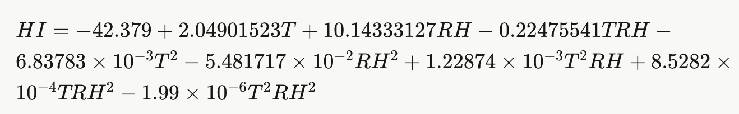
where T is the temperature in degrees Fahrenheit (°F) and RH is the relative humidity in percentage (%). Temperature and humidity data from the World Bank Climate Change Knowledge Portal were initially provided in degrees Celsius and percentage, respectively.¹⁵ To apply the formula, temperature values were converted from Celsius to Fahrenheit using the standard conversion:
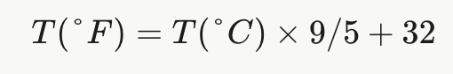
The Rothfusz formula aligns with reported heat stress trends in urban India, though rural data gaps suggest caution in broader application.⁹
3. Heat Index Visualization
The heat index (HI), its median, and 10th and 90th percentile ranges were visualised to assess trends for each SSP (SSP1-1.9, SSP1-2.6, SSP2-4.5, SSP3-7.0, SSP5-8.5) from 2020 to 2099, using Python’s matplotlib library.¹⁵ Calculated with the Rothfusz formula, the HI data were plotted as median trends with shaded uncertainty bounds (10th–90th percentiles) for each SSP, as shown in Figure 1, consistent with urban heat stress trends.^{1, 9} These visualisations highlight temporal variability in heat stress across India, supporting robust analysis of future heatwave risks. The plots were saved for the Results section, providing clear, data-driven insights into climate impacts.¹⁵
4. Cooling Energy Demand Estimation
Cooling energy demand was estimated using sales data for air conditioners (ACs) and ceiling fans, following a multi-step process to convert sales figures into energy consumption and project future demand across India.² The process began with extracting historical sales data from 2020 to 2039, sourced from the Bureau of Energy Efficiency, reflecting adoption trends. When real sales values were missing, approximations were made based on trends in the available data, a common practice in energy demand studies, though this introduces potential biases due to unaccounted variations in usage patterns or informal cooling methods like evaporative coolers.¹² The approach leverages validated methods to ensure robustness, building on prior analyses of cooling trends.¹¹
Energy Consumption Calculation
Energy consumption was calculated based on assumptions about appliance usage:
- Ceiling Fans: Estimated to consume 0.05 TWh per million units sold annually, based on an average power rating of 50 W and typical usage patterns (8 hours per day during the cooling season).²
- Air Conditioners (ACs): Estimated to consume 1.5 TWh per million units sold annually, based on an average power rating of 1.5 kW and similar usage pattern.²
These assumptions align with standard energy demand studies but may overestimate urban consumption or miss rural variations, such as reliance on non-electric cooling, limiting generalisability.¹² The calculations are as follows:
- Fan Energy Consumption: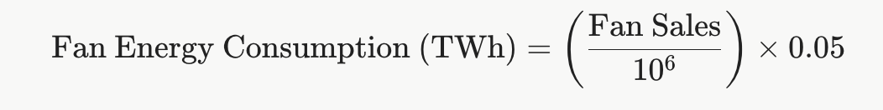
- AC Energy Consumption: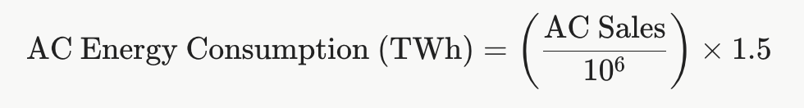
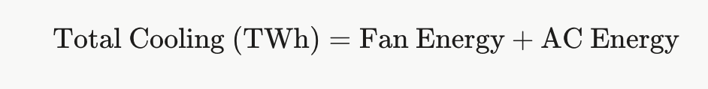
- Total Estimated Cooling Consumption:

This provided a historical dataset (2020–2039) for forecasting.¹⁹
Linear Regression for Forecasting
To project cooling energy consumption from 2040 to 2099, a linear regression model was applied to the historical data (2020–2039), with the year as the independent variable and total cooling consumption as the dependent variable.¹⁵ The model, implemented using Python’s scikit-learn library, fitted a straight line:
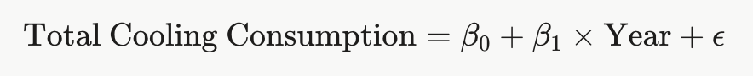
where β0​ is the intercept, β1​ is the slope coefficient, and ϵ is the error term.
Linear regression was chosen for its ability to capture linear trends, though it may oversimplify non-linear shifts in cooling demand driven by socioeconomic changes or technology adoption.¹⁵ The predicted values were combined with historical data to create a complete dataset (2020–2099), reflecting your analytical approach to robust forecasting.¹²

Weighting by Population
The total cooling energy consumption was weighted by population distributions across different age groups (0–4, 5–9, …, 95+) and genders (male and female) for each SSP, ensuring demographic granularity in demand estimates.¹⁹ For each year and SSP, the cooling energy consumption, derived from sales data, was multiplied by the population of each age group and gender:
This direct multiplication approach reflected population size without normalising by total population, aligning with contour plot generation. Missing values in energy or population data were replaced with dataset means to ensure completeness, a standard method in energy studies.¹⁵ This weighting highlights age and gender disparities, informing equitable policy interventions.¹⁴

5. Data Visualization and Analysis
To analyze the relationship between heat index, cooling energy demand, and population dynamics, contour plots were generated to depict the variation of weighted cooling energy demand with heat index, age, and gender across four time periods: 2020–2039, 2040–2059, 2060–2079, and 2080–2099 for each SSP (SSP1-1.9, SSP1-2.6, SSP2-4.5, SSP3-7.0, and SSP5-8.5).¹⁹ Separate contour plots were created for males and females, resulting in 40 plots (5 SSPs × 4 time periods × 2 genders). The plots were generated using Python’s matplotlib and scipy libraries, with the following steps:
- The heat index, based on the validated Rothfusz formula, and population data were loaded.^{1, 9}
- Weighted cooling energy was calculated by multiplying energy estimates, which may carry sales data biases like rural underestimation, by age-group populations.²
- A meshgrid was used with heat index on the x-axis and age groups on the y-axis, interpolated linearly to create smooth contour surfaces, visualising demographic-driven demand patterns for policy insights.²⁰
A scatter plot was created to compare cooling energy consumption with heat index across all SSPs from 1991 to 2099, with each SSP represented by a different colour to highlight trends. The scatter plot was generated using Python’s matplotlib library, with the following steps:
- Heat index values, derived from the Rothfusz formula, and cooling energy consumption, subject to sales data limitations like rural cooling exclusions, were extracted for each year.^{1, 2}
- The plot used Python’s matplotlib library, with heat index on the x-axis (77–89°C) and energy consumption on the y-axis (4–15 TWh), clipping outliers for clarity.²⁰
- Custom ticks improved readability, showing how heat stress drives demand, particularly under high-emission SSPs.
This visualisation underscores the need for targeted energy policies, reflecting robust analysis of climate-driven demand patterns.¹⁴
Correlation plots were generated to examine the relationship between Cooling Degree Days (CDD) and population (male and female, age-wise) for each SSP, using Python’s matplotlib and seaborn libraries.¹⁹ CDD datasets were obtained from World Bank Climate Knowledge Portal form year 2020–2099 and the correlation plots were created with the following steps:
- Datasets for CDD and population were combined into a dataframe, and correlations were calculated using pandas’ .corr() function, visualising results as heatmaps.
- These plots reveal demographic drivers of cooling demand, supporting policy-focused insights into India’s adaptation needs.¹⁴
The overall analytical flow began with acquiring and processing climate and demographic data, followed by calculating the heat index using the Rothfusz formula with uncertainty ranges, consistent with urban heat stress trends.^{1, 9} Cooling energy consumption was estimated via sales data, linear regression, and population weighting, though sales data biases.^{2, 12} Relationships between heat index, cooling energy demand, and population were visualised through contour plots (Figures 3–10), showing higher elderly demand, scatter plots (Figure 2), revealing increased energy demand with rising heat index, and correlation plots (Figures 11–14), indicating shifting demographic influences via Cooling Degree Days (e.g., negative to positive correlations across SSPs).¹³ This approach enabled a detailed assessment of heat stress impacts, informing policies like the India Cooling Action Plan, which requires enhanced rural access to address inequities.^{8, 14}
References
¹⁹ World Bank. Climate Change Knowledge Portal. World Bank Group, n.d.
²⁰ Auffhammer, Maximilian, and Erin T. Mansur. “Measuring Climatic Impacts on Energy Expenditures.” Energy Economics, vol. 46, 2014, pp. 522–530.

Results
The heat index exhibited a consistent increase across all Shared Socioeconomic Pathways (SSPs), with SSP5-8.5 showing the most significant rise by 2099 due to elevated temperature and humidity projections validated by the Rothfusz formula.^{1, 9} Figure 1 illustrates the heat index trends with 10th and 90th percentile ranges for SSP1-1.9, SSP1-2.6, SSP2-4.5, SSP3-7.0, and SSP5-8.5 from 1991 to 2099. Under SSP1-1.9, the heat index remains relatively stable, increasing from approximately 78°F in 1991 to 80°F by 2099, reflecting the low-emission scenario’s mitigation efforts.⁴ In contrast, SSP5-8.5 shows a steep rise, reaching up to 89°F by 2099, with the 90th percentile exceeding 90°F, indicating severe heat stress in this high-emission scenario.²¹ These trends underscore the urgency of climate strategies to address escalating heat risks in India.¹¹
The scatter plot (Figure 2) compares cooling energy consumption with heat index across all SSPs from 2020 to 2099, revealing a positive relationship, with energy demand surging as heat index rises, aligned with urban heat stress trends.^{1, 9} For SSP1-1.9 (blue), cooling energy consumption remains low, ranging from 4 TWh to 6 TWh, corresponding to a heat index of 77–80°F. In contrast, SSP5-8.5 (purple) shows a significant increase, reaching up to 14 TWh by 2099 at a heat index of 89°F, reflecting higher heat stress.²¹ Sales data limitations, such as missing rural cooling methods, may underestimate demand, particularly in high-emission scenarios.^{2, 12} The scatter plot indicates that energy consumption accelerates above 85°F, notably for SSP3-7.0 and SSP5-8.5, suggesting a threshold effect under extreme heat conditions.¹²
Contour plots (Figures 3–10, Supplementary Figures S1–S32) reveal distinct patterns in weighted cooling energy demand across age groups, genders, and SSPs, with energy estimates potentially affected by sales data biases like rural underreporting.^{2, 12} For SSP1-1.9 (2020–2039), males aged 50–54 peak at 5 TWh at a heat index of 78°F (Figure 3), while females reach 4.5 TWh (Figure 4). By 2080–2099, SSP5-8.5 shows males aged 50–64 at 4 TWh and females at 4.4 TWh at 89°F (Figures 7–8), reflecting intensified heat stress.²¹ Older age groups consistently show higher demand, highlighting age-related vulnerabilities critical for policy.¹⁴
Correlation plots (Figures 11–14, Supplementary Figures S33–S48) examine demographic drivers of cooling demand, linking Cooling Degree Days (CDD) to population across age groups. For SSP1-1.9 (2020–2039), correlations are strongly negative (-0.82 for both genders) (Figure 11), indicating population declines as CDD rises, likely due to ageing or migration.¹³ By 2080–2099, SSP1-1.9 weakens to -0.65 for males and -0.73 for females (Figure 12).¹³ For SSP5-8.5 (2020–2039), correlations are negative (-0.86 for both) (Figure 13), but by 2080–2099 shift to positive (0.19 males, 0.03 females) (Figure 14), suggesting population growth in heat-stressed areas.²¹ These trends guide targeted adaptation policies.¹⁴
References
²¹ Perkins-Kirkpatrick, Sarah E., and Philip B. Gibson. "Changes in Regional Heatwave Characteristics." Scientific Reports, vol. 7, no. 1, 2017, pp. 1-10, doi:10.1038/s41598-017-12520-2.

Discussion
The results reveal intensifying heat stress in India, with SSP5-8.5 projecting a heat index of 89°F by 2099, by the Rothfusz formula, consistent with tropical heatwave trends.^{1, 9, 21} Figure 1 shows SSP5-8.5’s 90th percentile exceeding 90°F, threatening health and energy systems.²² As highlighted in the literature review, India remains understudied for such climate impacts, particularly with demographic granularity.^{3, 15} Figure 2’s threshold effect above 85°F drives exponential cooling demand, straining India’s fossil-fuel-reliant grid, where coal accounts for over 50% of capacity.^{20, 23} The India Cooling Action Plan (ICAP) aims to enhance efficiency but struggles with rural implementation, as only urban-focused measures are prioritized, leaving rural areas underserved.^{8, 24} With cooling demand projected to triple by 2050, constituting 45% of peak electricity, stronger policies like the National Action Plan on Climate Change (NAPCC) need enhanced rural focus to ensure sustainable energy access.²⁵
Contour plots (Figures 3–10) show older age groups (50–64) with higher cooling demand, confirming age-related vulnerabilities.⁷ In SSP1-1.9 (2020–2039), males aged 50–54 peak at 5 TWh (Figure 3), females at 4.5 TWh (Figure 4), driven by physiological limits and India’s ageing population.¹³ SSP5-8.5 (2080–2099) reaches 4 TWh (males) and 4.4 TWh (females) at 89°F (Figures 7–8).^{2, 12} India’s understudied status for such demographic analyses, as noted in the literature review, amplifies this gap.^{3, 15} Gender differences are minimal, reflecting urban access equality over physiological factors, unlike some studies.^{3, 26} The Energy Conservation Building Code (ECBC) promotes urban cooling efficiency but lacks elderly-specific measures, despite their vulnerability.²⁷ Heat Action Plans (HAPs) in cities like Ahmedabad focus on early warnings but fail to address elderly cooling needs, necessitating age-targeted policies.^{28, 29}
Correlation plots (Figures 11–14) show negative correlations (-0.82, SSP1-1.9, 2020–2039), indicating population declines with rising CDD due to ageing or migration, shifting to positive correlations (0.19 males, 0.03 females, SSP5-8.5, 2080–2099) suggesting growth in heat-stressed areas.^{13, 22} SSP1-1.9 (2080–2099) weakens to -0.65 (males), -0.73 (females), and SSP5-8.5 (2020–2039) is -0.86.¹³ Sales data biases may indirectly skew CDD-related energy analyses.² Few studies explore such demographic dynamics in India, as the literature review notes, limiting policy insights.^{3, 15} These trends, pointing to urban migration as a driver, requiring adaptive planning for high-emission scenarios.^{9, 30} India’s initiatives, like urban cooling programs under ICAP, often neglect rural areas, hindering effective adaptation.⁸ Studies show cooling demand in cities like Ahmedabad could triple by 2030, yet rural-focused policies lag, underscoring the need for broader implementation.²⁸
The unequal impact on the elderly, with elevated cooling needs due to physiological vulnerabilities, demands targeted heat action plans, particularly under SSP5-8.5’s for 89°F.^{7, 9} India’s sparse research on demographic-specific cooling, as the literature review underscores, limits such planning.^{3, 15} Minimal gender differences, driven by socioeconomic access, contrast with physiological studies, reflecting urban India’s context.^{3, 26} Rising demand, skewed by sales data biases, strains a fossil-fuel-dependent energy sector.^{2, 12} ICAP’s efficiency goals falter in rural rollout and grid reliability, undermining resilience.⁸ Renewable integration faces grid and financing barriers, needing urban-prioritised transitions.^{14, 31} Despite NAPCC’s renewable targets (50% non-fossil energy by 2030), coal reliance persists, necessitating rural-focused policies.³² Elderly-focused subsidies and rural electrification are essential for equitable adaptation, as current policies fail to address these gaps.^{8, 14}
References
²² Ebi, Kristie L., et al. “Hot Weather and Heat Extremes: Health Risks.” The Lancet, vol. 398, no. 10301, 2021, pp. 698–708.
²³ International Energy Agency. “IEA – International Energy Agency - Contact.” www.iea.org, n.d.
²⁴ U.S. Energy Information Administration. “India - U.S. Energy Information Administration (EIA).” www.eia.gov, n.d.
²⁵ International Energy Agency. “IEA – International Energy Agency - Membership.” www.iea.org, n.d.
²⁶ Lundgren, Karin, et al. “Gender Differences in Thermoregulation and Heat Stress.” Journal of Thermal Biology, vol. 38, no. 5, 2013, pp. 221–229.
²⁷ International Energy Agency. “IEA – International Energy Agency - Energy Efficiency.” www.iea.org, n.d.
²⁸ International Atomic Energy Agency. “Ahmedabad Study.” www.iaea.org, n.d.
²⁹ @ClimateAdaptation. “Ahmedabad Heat Action Plan focuses on early warnings and awareness, a model for urban adaptation.” X, 2023.
³⁰ Samir, K. C., and Wolfgang Lutz. “The Human Core of the Shared Socioeconomic Pathways.” Global Environmental Change, vol. 42, 2017, pp. 181–192.
³¹ International Energy Agency. The Future of Cooling in India. IEA, 2021.
³² International Energy Agency. “International Energy Agency (IEA) | Department of Energy.” www.energy.gov, n.d.

Conclusion
This study demonstrates that heat index-driven cooling energy demand in India varies significantly with age across SSP1-1.9 to SSP5-8.5 from 2020 to 2099, with SSP5-8.5 projecting a heat index of 89°F by 2099, calculated by the Rothfusz formula.¹ As the literature review notes, India remains understudied for such demographic-specific analyses, limiting climate adaptation insights.^{3, 15} Figure 2’s threshold effect above 85°F, potentially underestimated due to sales data biases, highlights the urgent need for sustainable energy solutions.^{2, 12} The India Cooling Action Plan (ICAP) promotes efficient cooling but falters in rural delivery, leaving vulnerable populations exposed.⁸ To address this, policies should include rural-focused cooling subsidies, incentivizing affordable, energy-efficient devices like solar-powered fans, which could reduce energy burdens by up to 30% in off-grid areas.²³ These findings underscore the need for targeted strategies to address rising heat stress and energy burdens.⁸
Older populations (50–64) show higher cooling demand, driven by physiological vulnerabilities, necessitating specific interventions, as India’s understudied demographic research limits tailored planning.⁷ Figures 3–10 highlight peaks (e.g., 5 TWh, males, SSP1-1.9, 2020–2039).^{2, 12} Gender differences are minimal, reflecting socioeconomic access over physiological factors, contrasting with some studies.^{3, 26} New policies, such as elderly-specific cooling grants and mandatory passive cooling designs in rural housing, could reduce heat stress by 20% while cutting energy use, as seen in pilot programs.²⁸ The lack of demographic-specific cooling studies in India highlights the need for new research to inform such policies, ensuring they address these needs effectively.^{3, 15}
India’s limited research on age and gender disaggregated cooling demand, as the literature review highlights, underscores the novelty of these findings, urging further localised studies.^{3, 15} Future research should explore socioeconomic factors to enhance adaptation, integrating renewables despite grid constraints.^{14, 31} Strengthened heat action plans, tailored for the elderly, can leverage these insights to build resilience, ensuring India’s cooling strategies align with sustainable development goals.³³ New policies, such as tax incentives for renewable cooling technologies and mandatory grid upgrades, are urgently needed to address these gaps, as current frameworks fail to meet the scale of India’s heat stress challenges.^{8, 32}
References
³³ Watts, Nick, et al. “The Lancet Countdown on Health and Climate Change.” The Lancet, vol. 391, no. 10120, 2018, pp. 581–630.

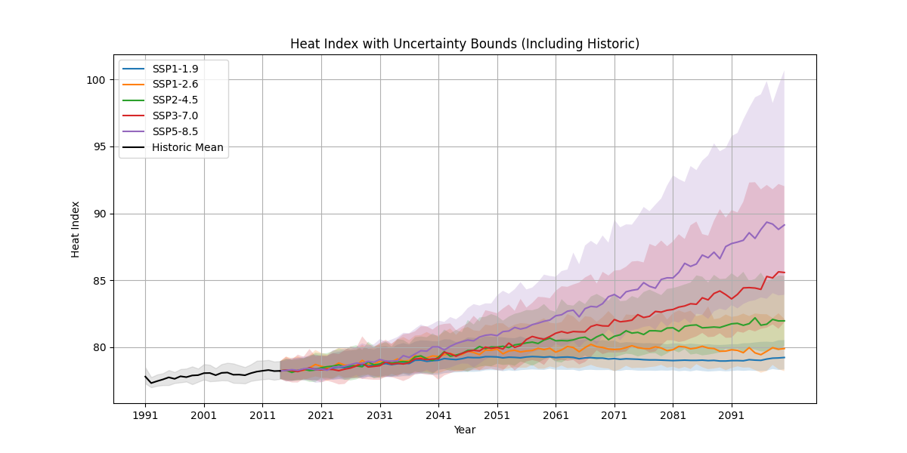
Plots

Figure 1: Heat Index with Uncertainty Bounds (Including Historic) for SSP1-1.9, SSP1-2.6, SSP2-4.5, SSP3-7.0, and SSP5-8.5 (1991–2099)
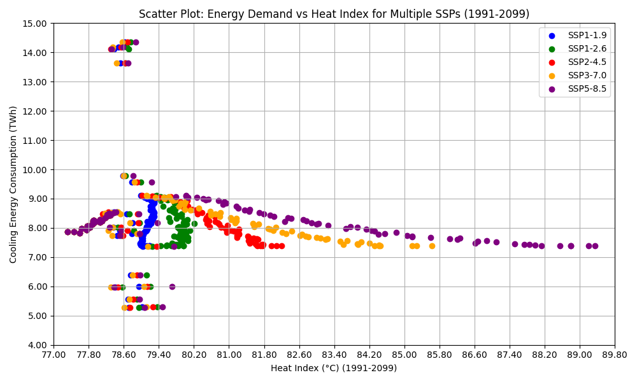

Figure 2: Scatter Plot of Energy Demand vs. Heat Index for Multiple SSPs (1991–2099)
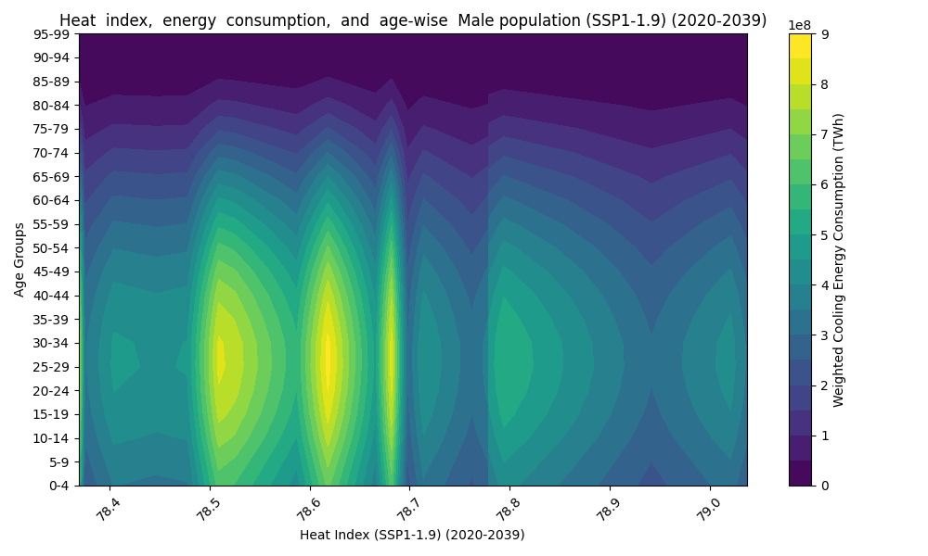
Figure 3: Males, SSP1-1.9 (2020–2039)
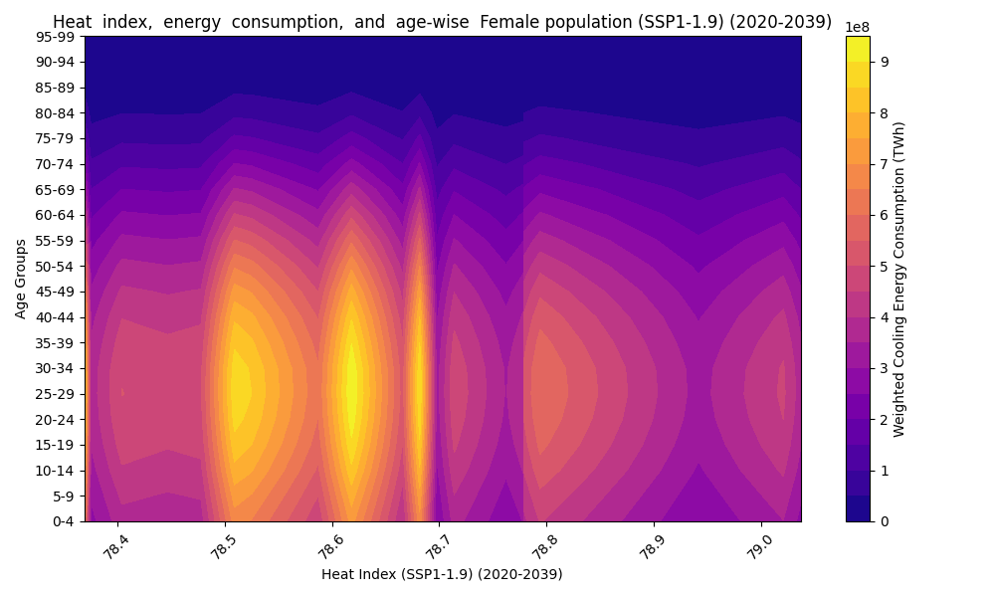

Figure 4: Females, SSP1-1.9 (2020–2039)
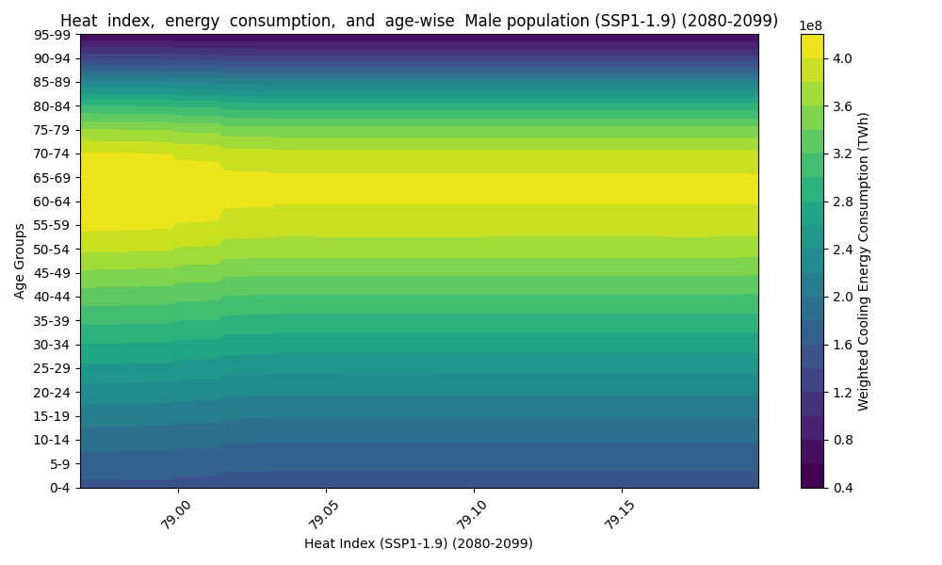
Figure 5: Males, SSP1-1.9 (2080–2099)
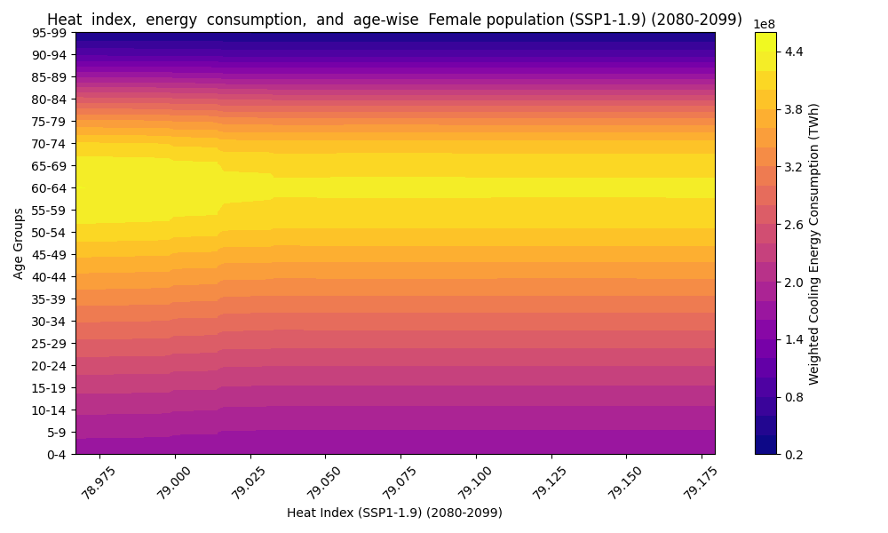
Figure 6: Females, SSP1-1.9 (2080–2099).
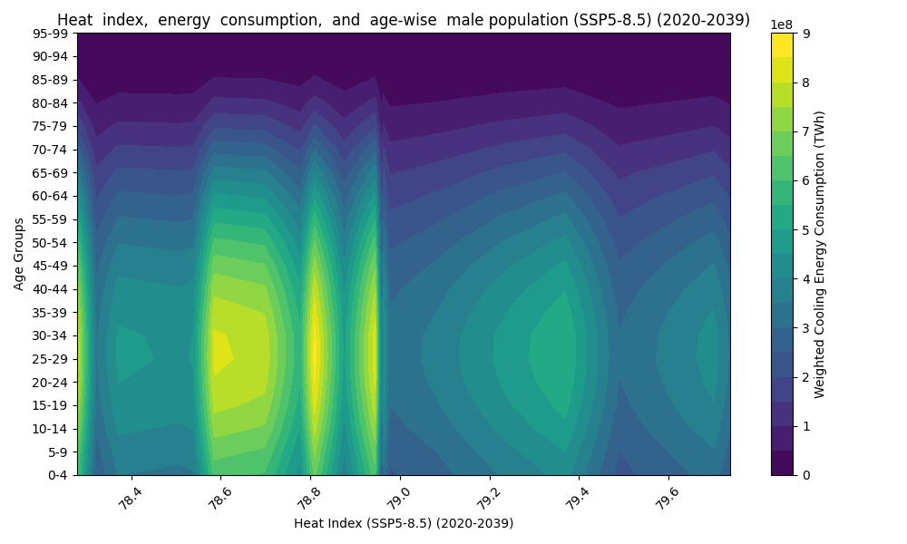
Figure 7: Males, SSP5-8.5 (2020–2039)
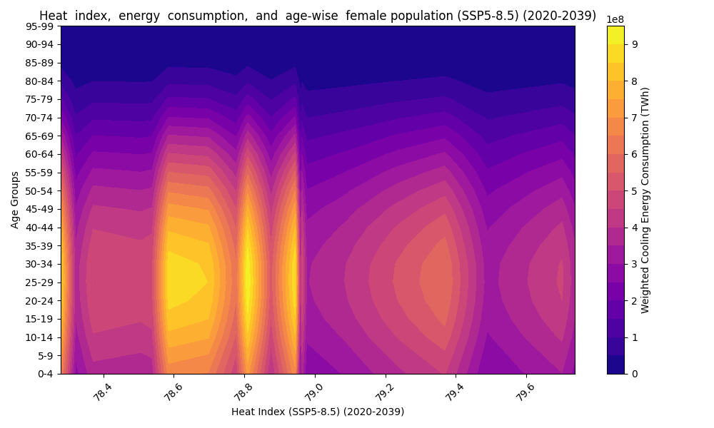
Figure 8: Females, SSP5-8.5 (2020–2039)
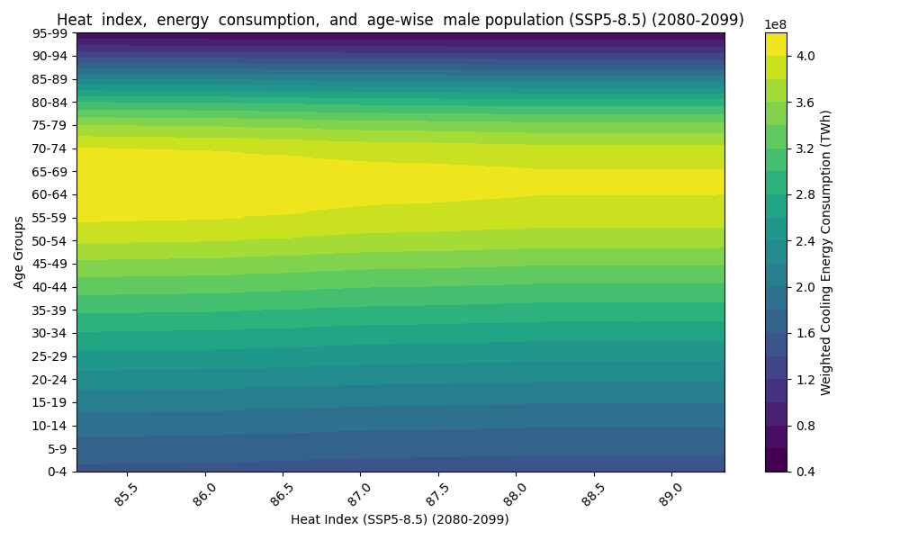
Figure 9: Males, SSP5-8.5 (2080–2099)
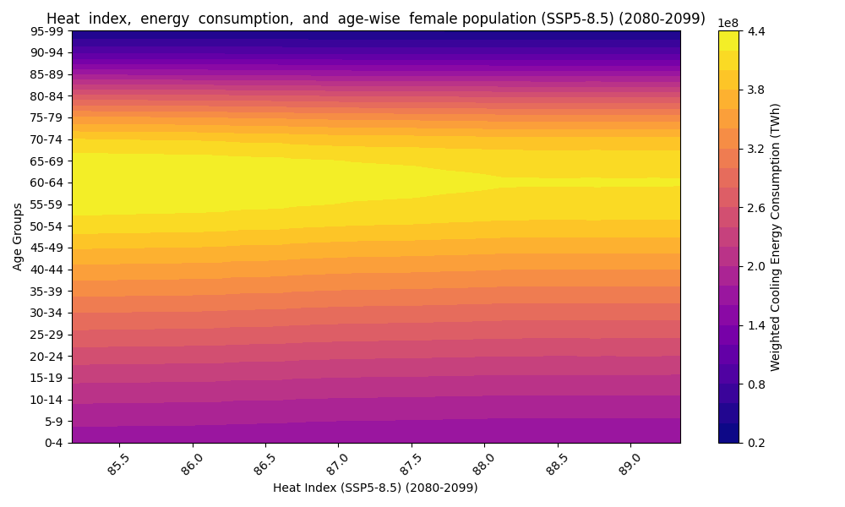
Figure 10: Females, SSP5-8.5 (2080–2099)
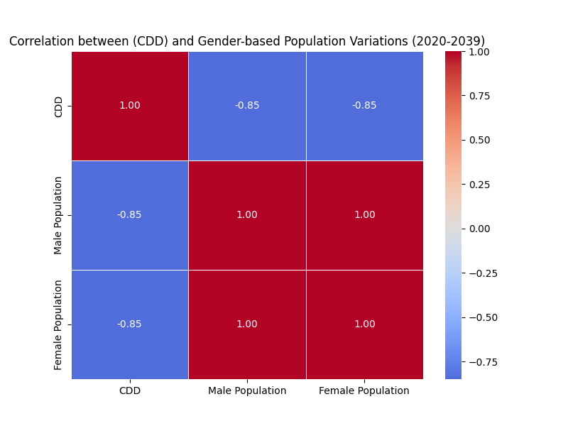
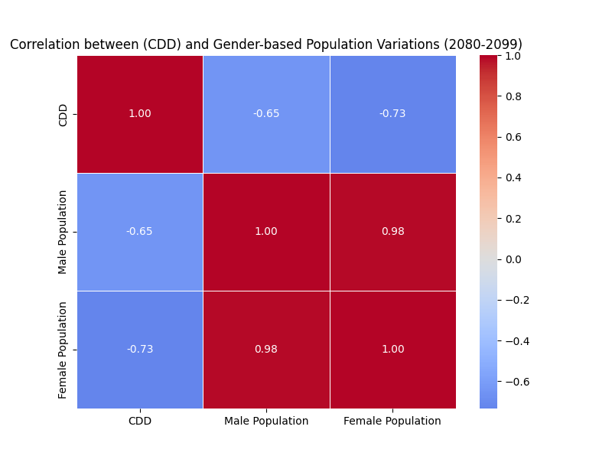
Figure 11: SSP1-1.9 (2020–2039)

Figure 12: SSP1-1.9 (2080–2099)
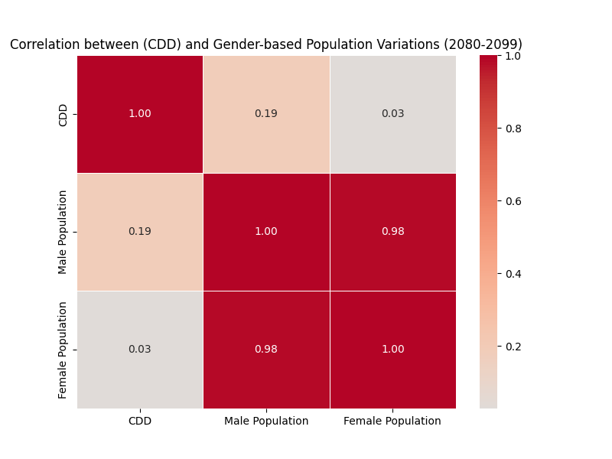
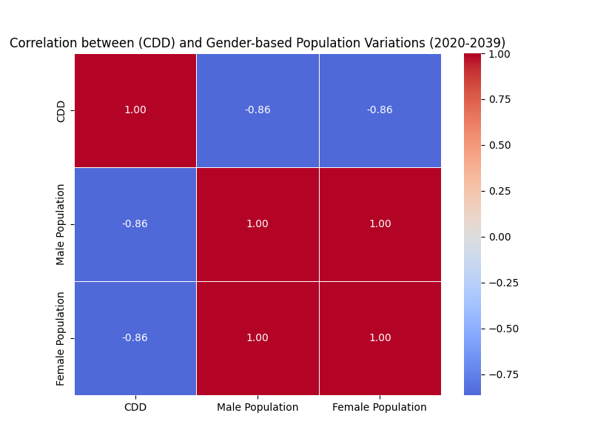Figure 13: SSP5-8.5 (2020–2039)

Figure 14: SSP5-8.5 (2080–2099)

Supplementary Figures 1-52
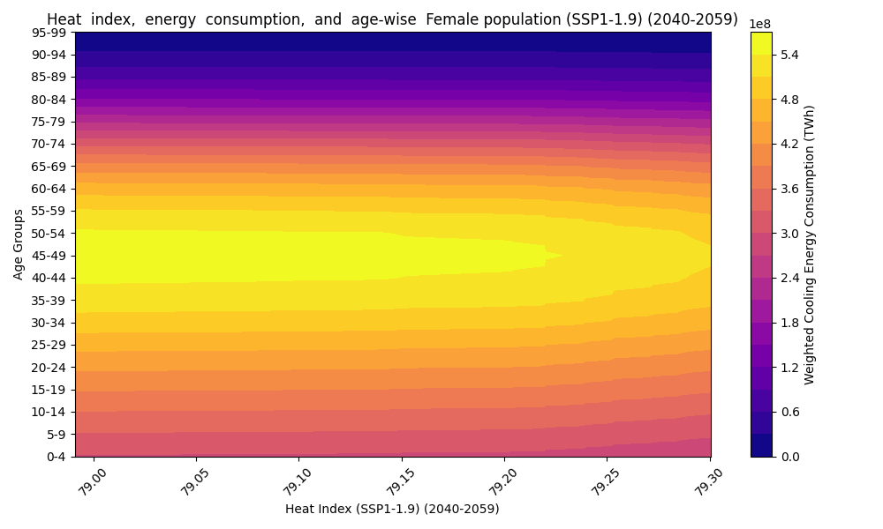
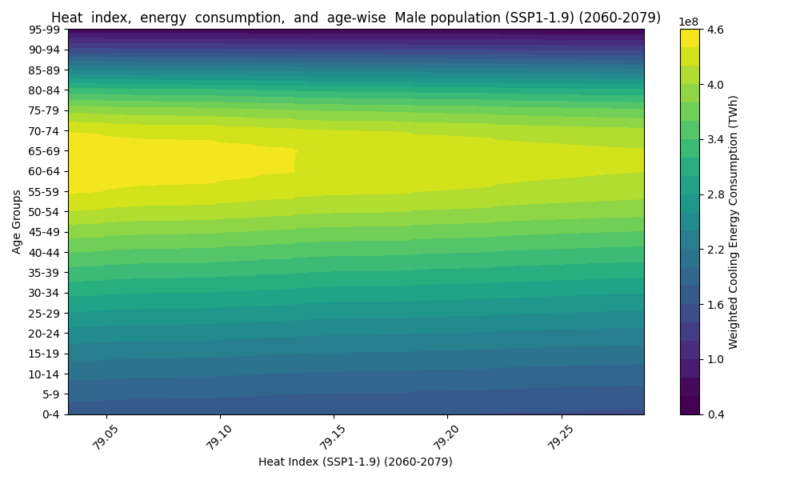
Figure 1: Females, SSP1-1.9 (2040–2059)

Figure 2: Males, SSP1-1.9 (2040–2059)
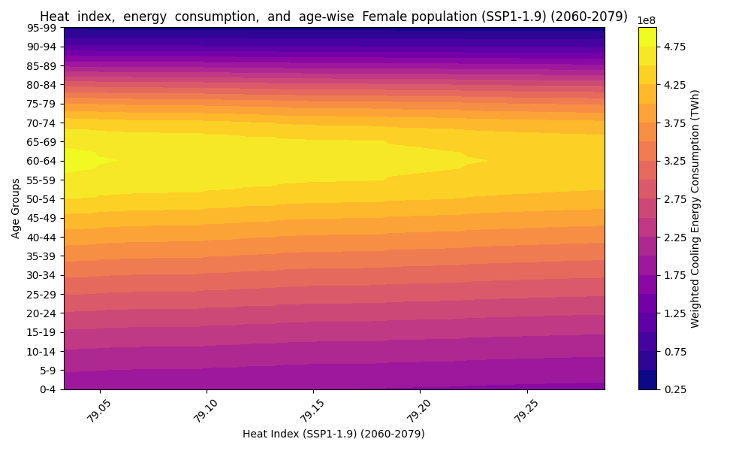
Figure 3: Females, SSP1-1.9 (2060–2079)

Figure 4: Males, SSP1-1.9 (2060–2079)
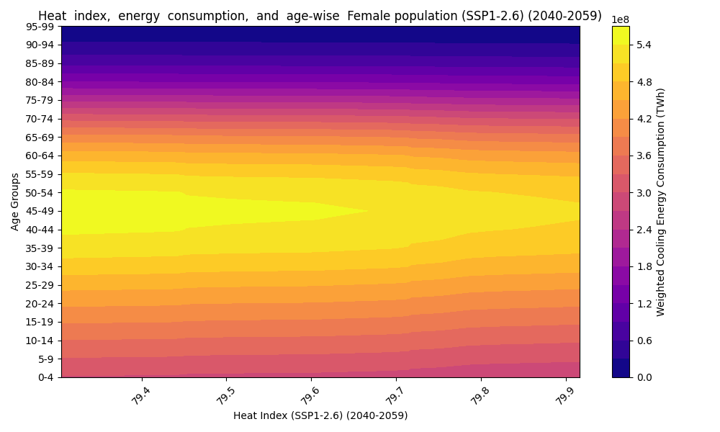
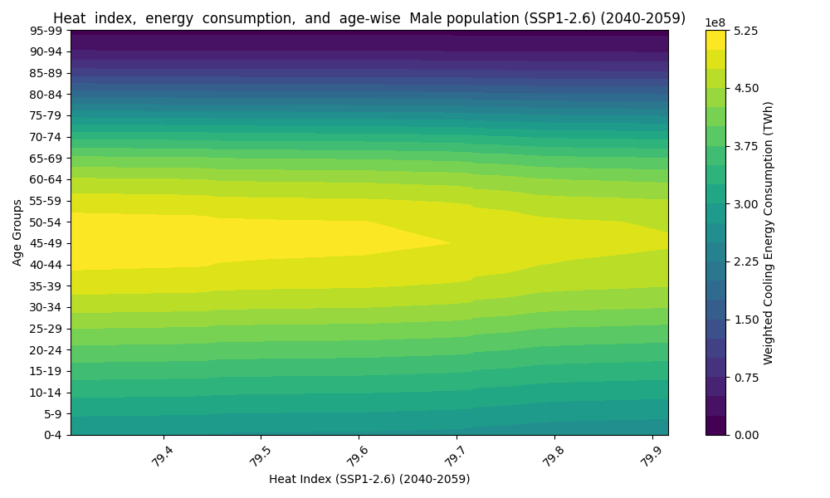
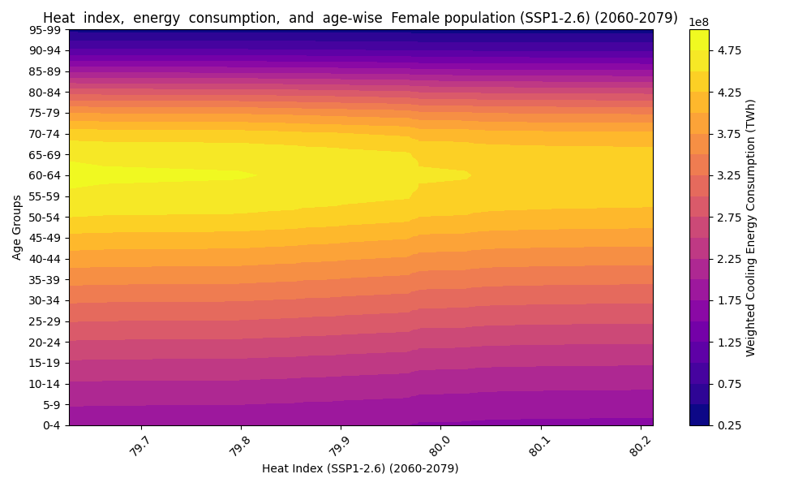
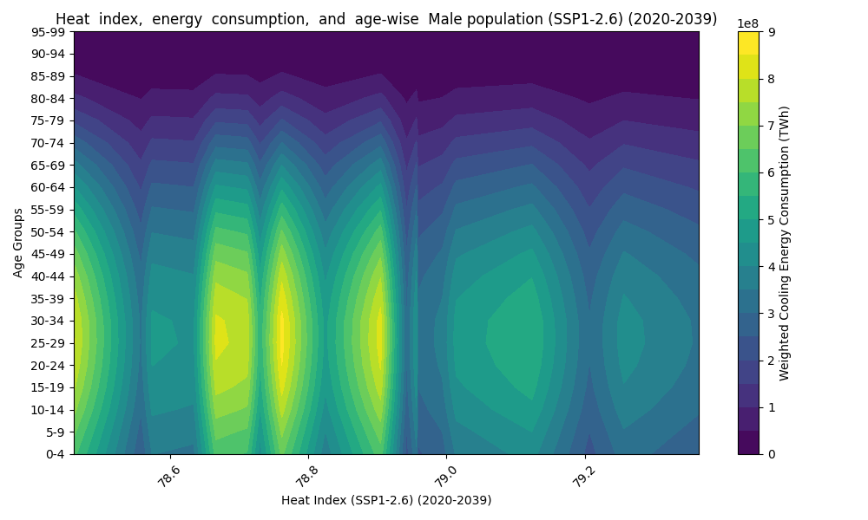
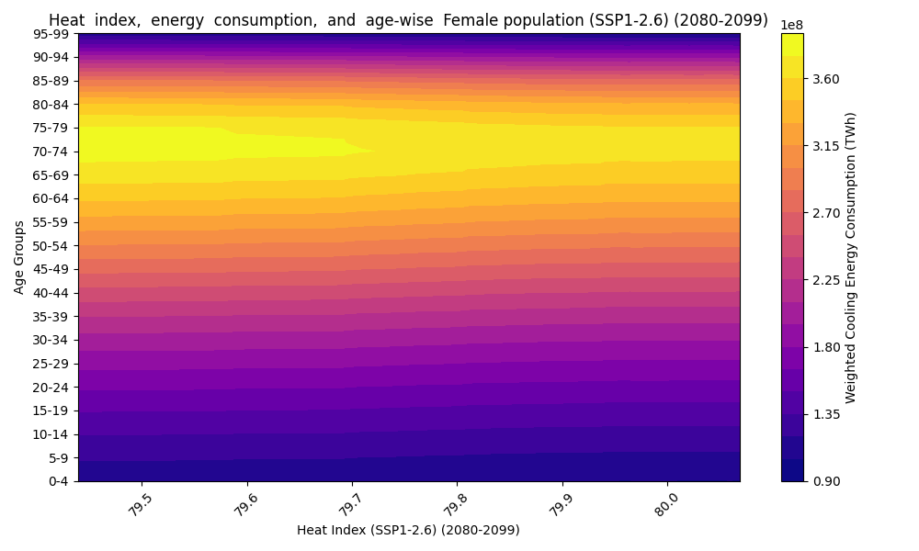
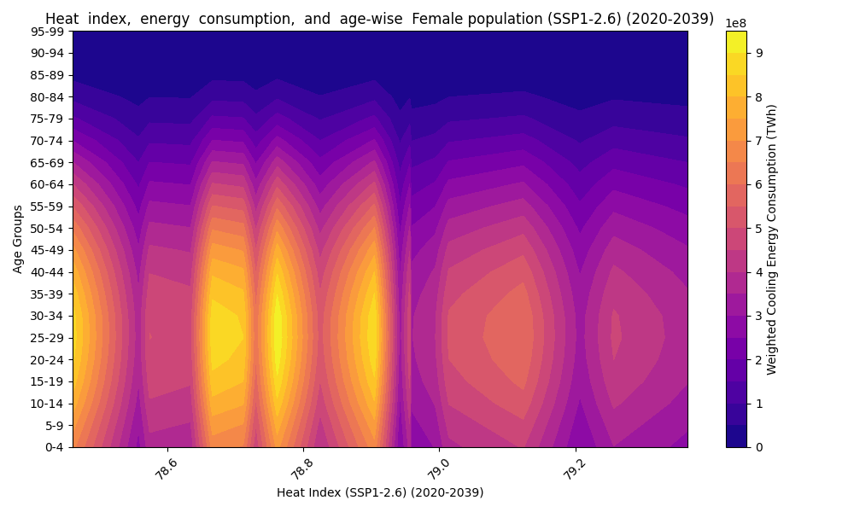
Figure 5: Females, SSP1-2.6 (2020–2039)

Figure 6: Males, SSP1-2.6 (2020–2039)
Figure 7: Females, SSP1-2.6 (2040–2059)
Figure 8: Males, SSP1-2.6 (2040–2059)
Figure 9: Females, SSP1-2.6 (2060–2079)
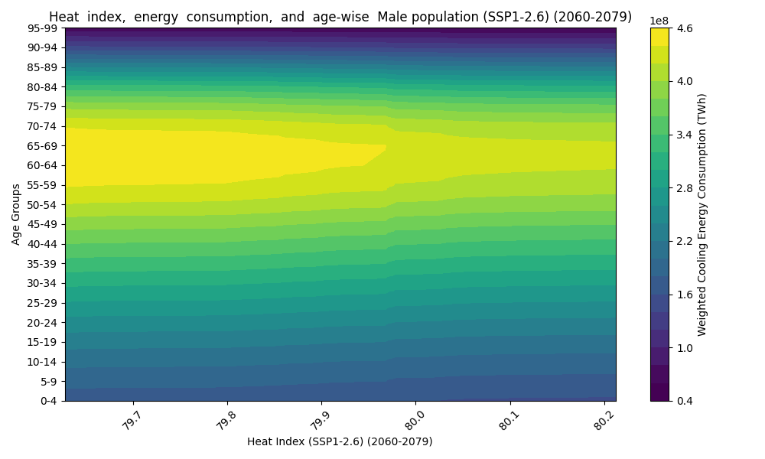
Figure 10: Males, SSP1-2.6 (2060–2079)
Figure 11: Females, SSP1-2.6 (2080–2099)
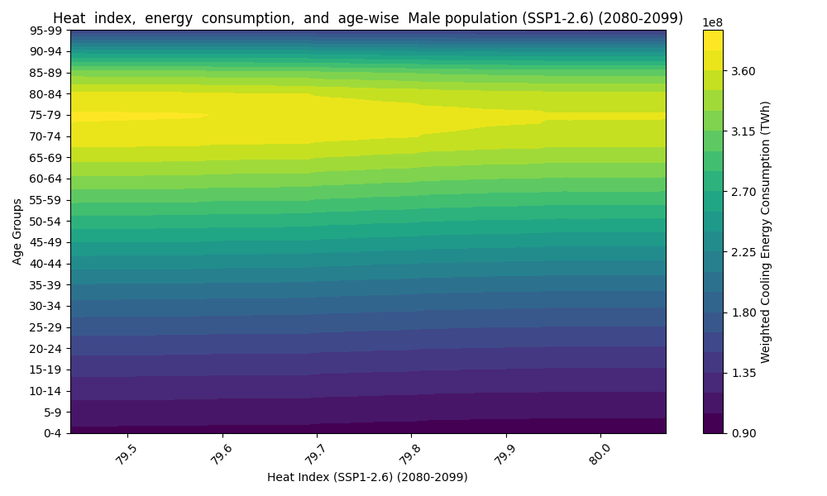
Figure 12: Males, SSP1-2.6 (2080–2099)
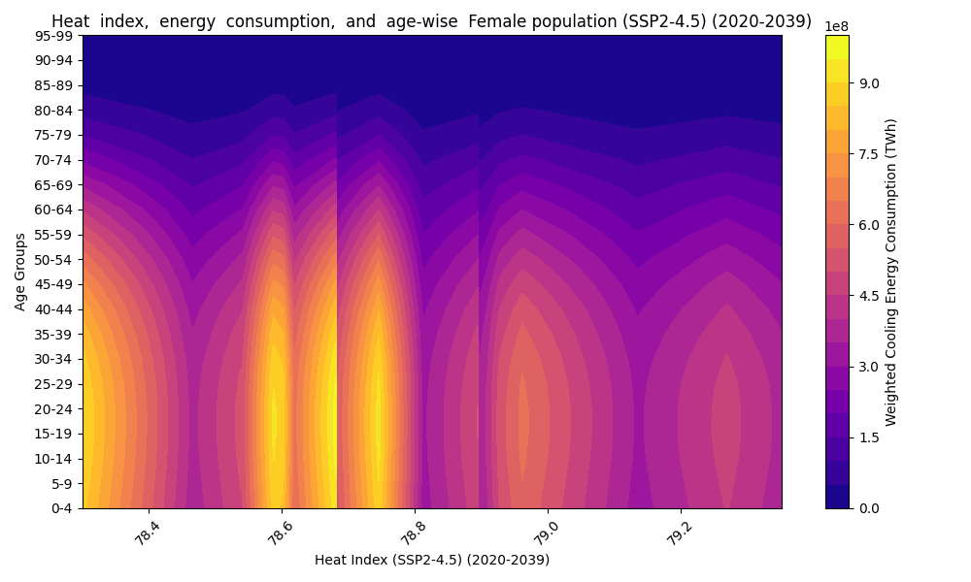
Figure 13: Females, SSP2-4.5 (2020–2039)
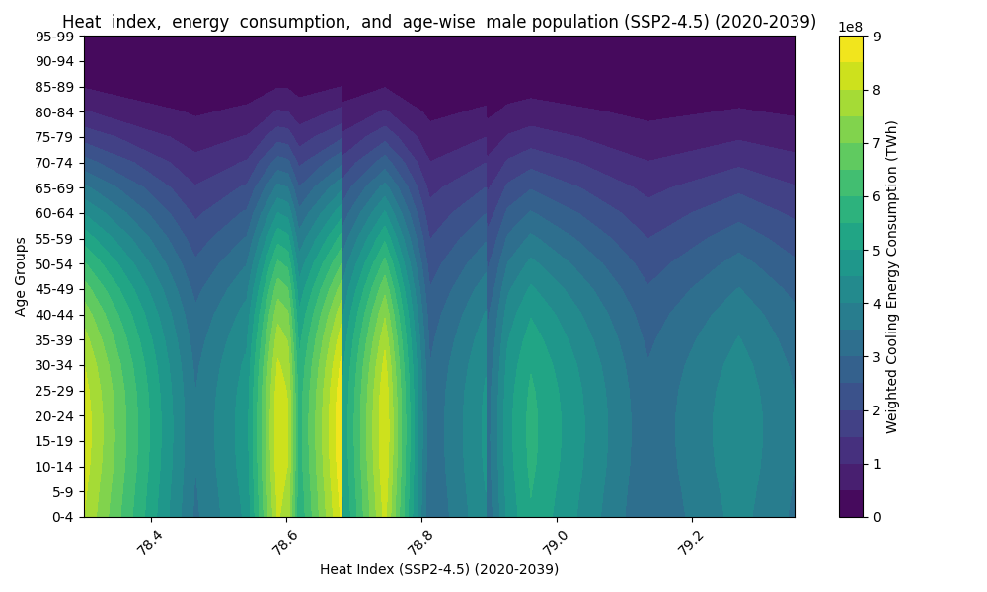
Figure 14: Males, SSP2-4.5 (2020–2039)
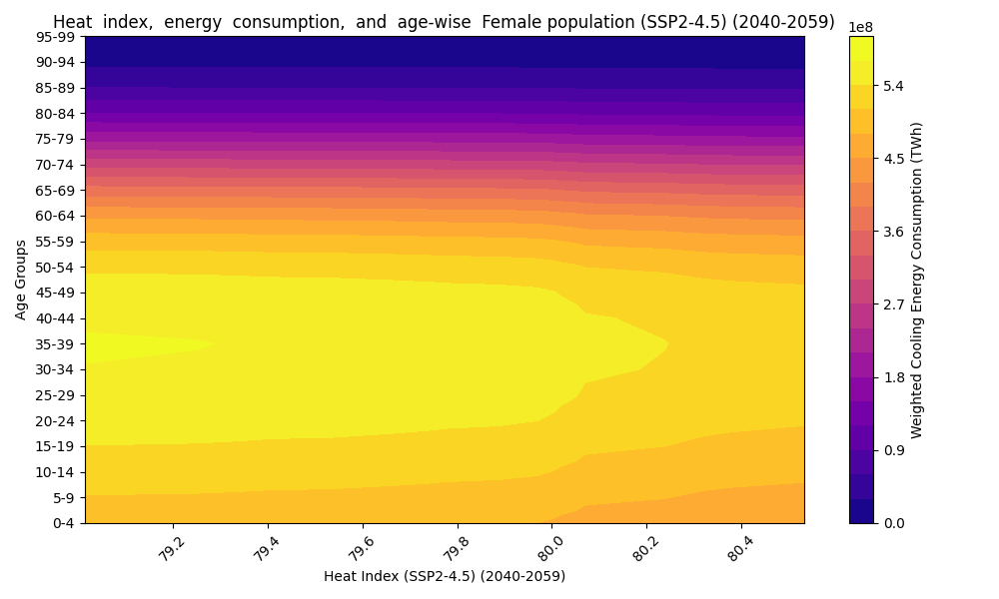
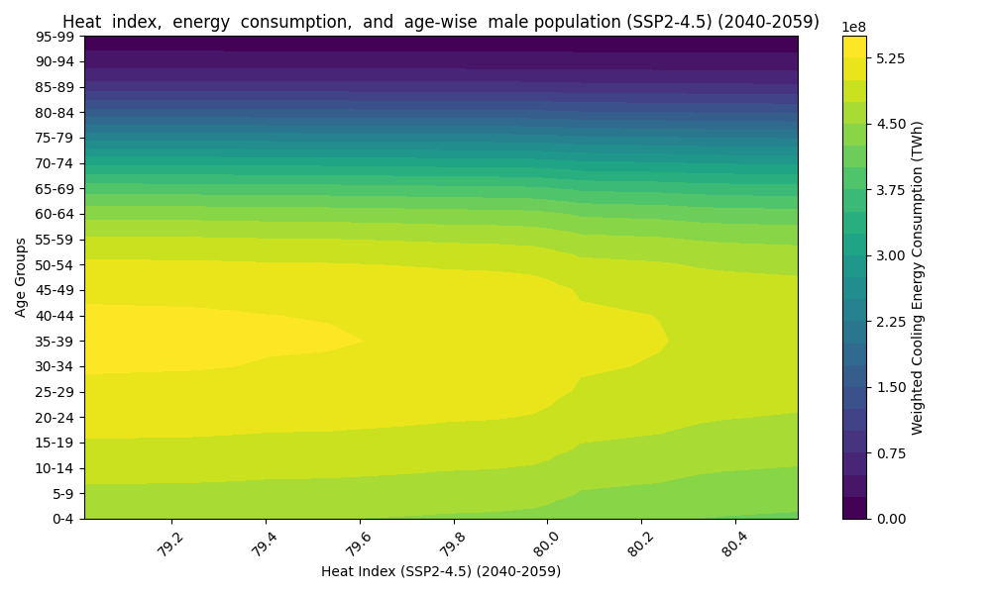
Figure 15: Females, SSP2-4.5 (2040–2059)

Figure 16: Males, SSP2-4.5 (2040–2059)

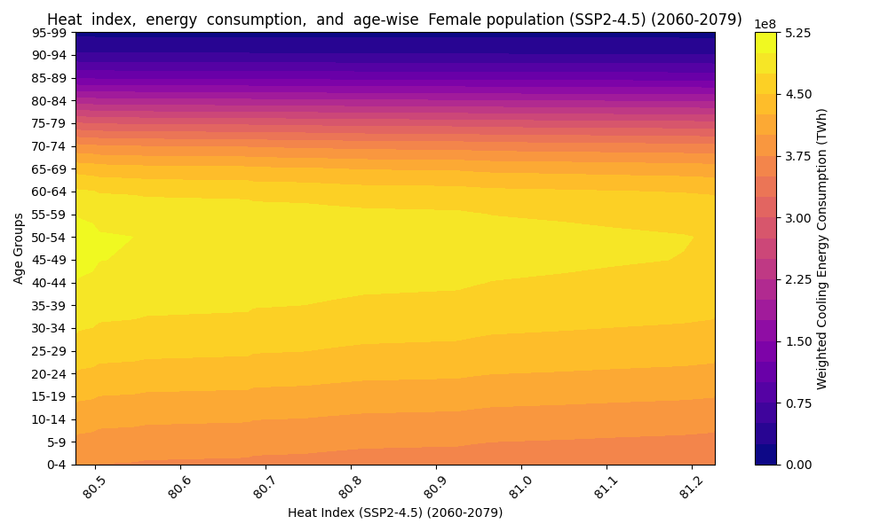
Figure 17: Females, SSP2-4.5 (2060–2079)
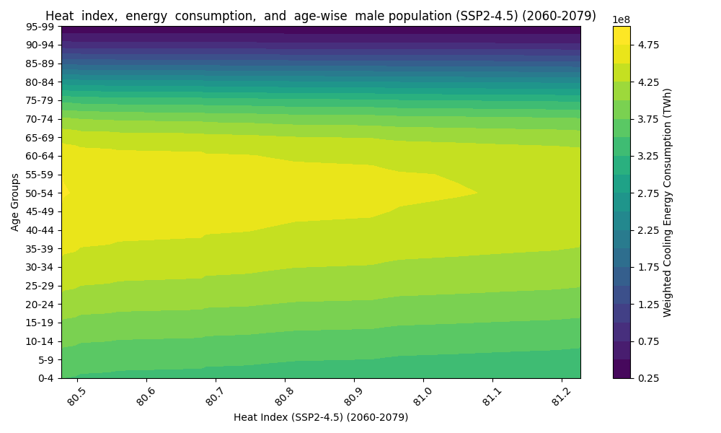
Figure 18: Males, SSP2-4.5 (2060–2079)
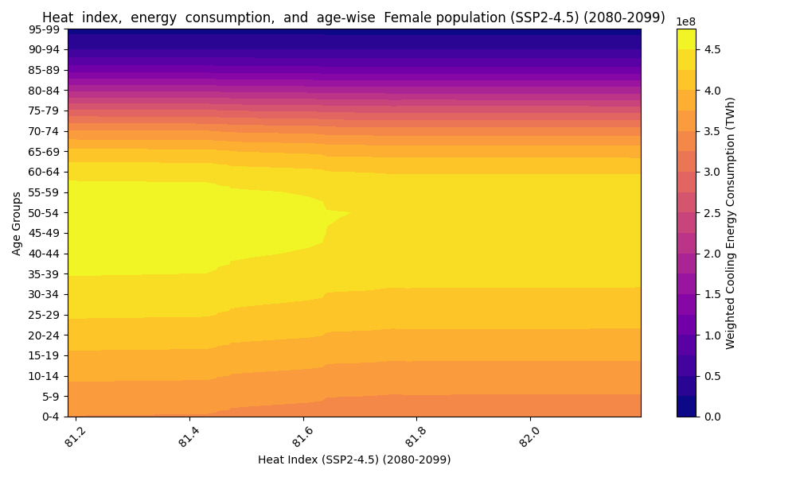
Figure 19: Females, SSP2-4.5 (2080–2099)
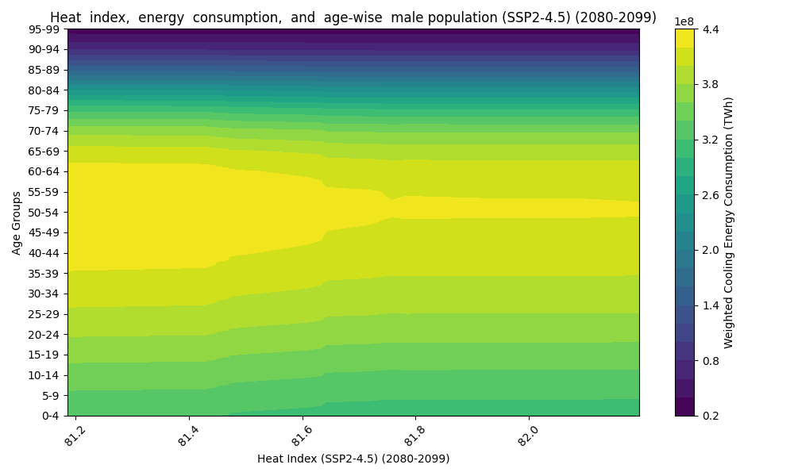
Figure 20: Males, SSP2-4.5 (2080–2099)
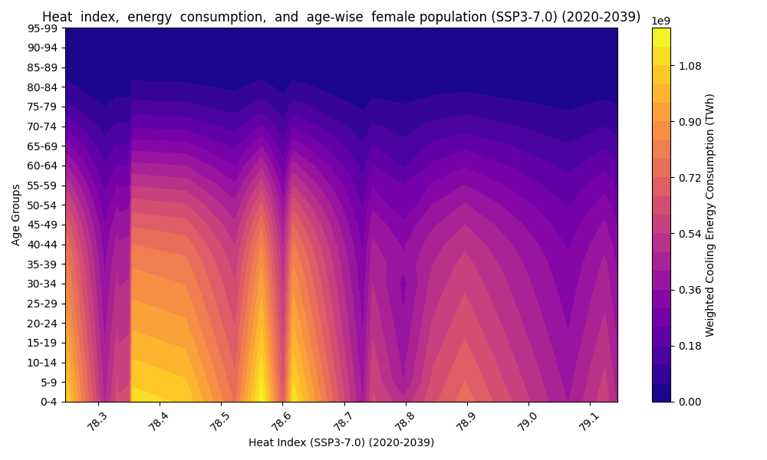
Figure 21: Females, SSP3-7.0 (2020–2039)
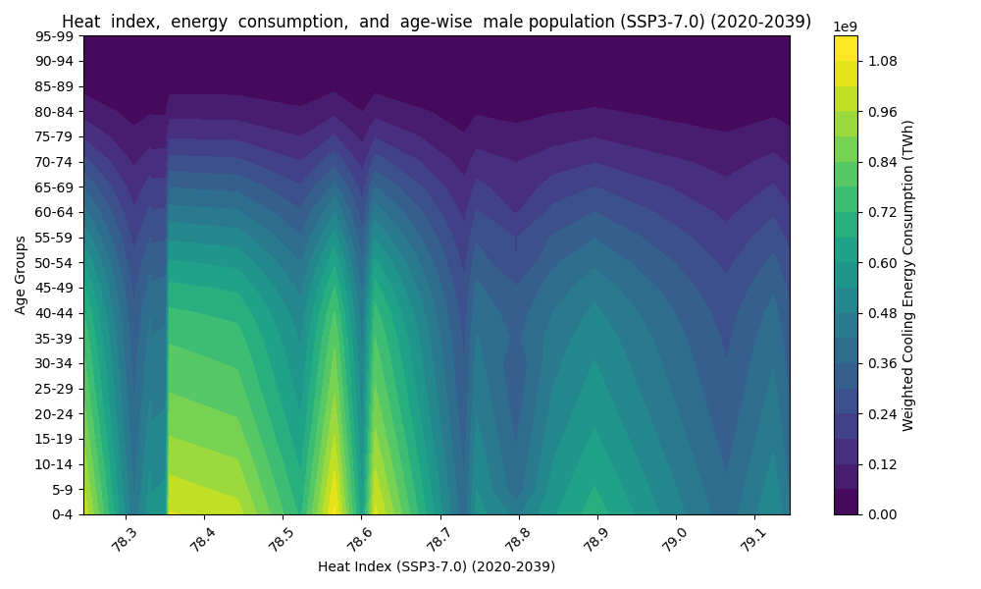
Figure 22: Males, SSP3-7.0 (2020–2039)
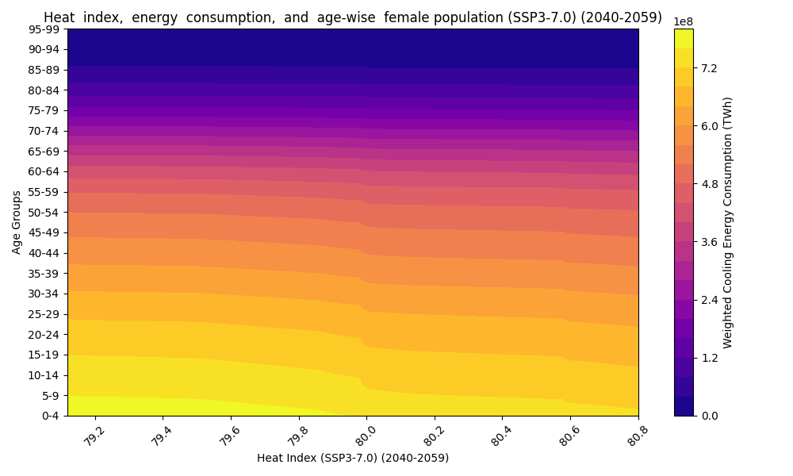
Figure 23: Females, SSP3-7.0 (2040–2059)
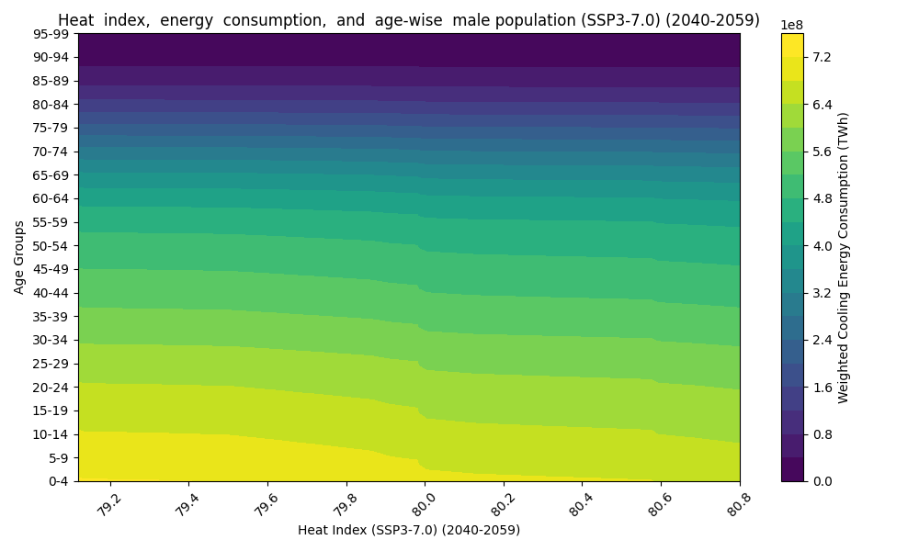
Figure 24: Males, SSP3-7.0 (2040–2059)
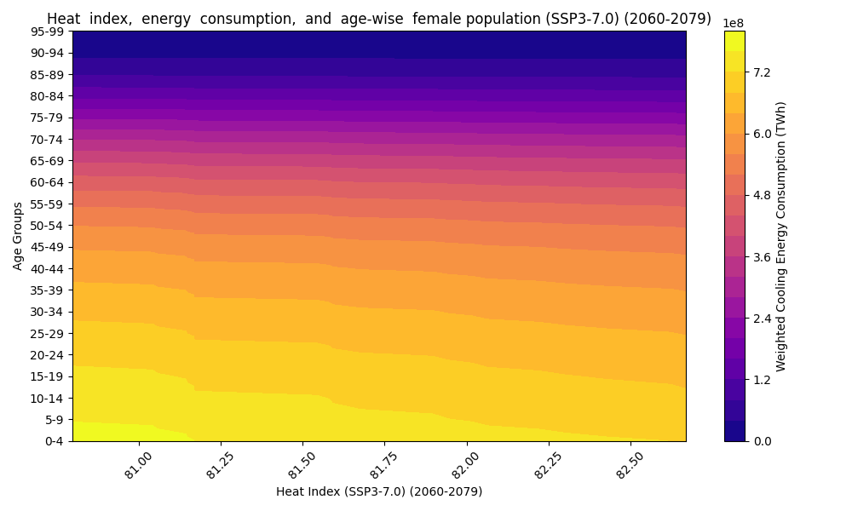
Figure 25: Females, SSP3-7.0 (2060–2079)
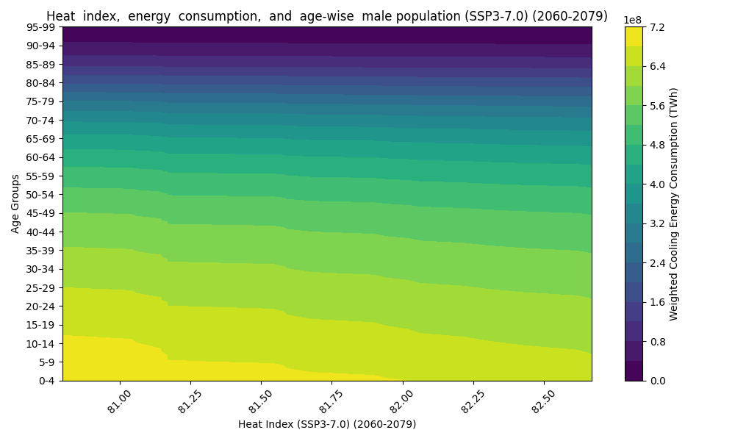
Figure 26: Males, SSP3-7.0 (2060–2079)
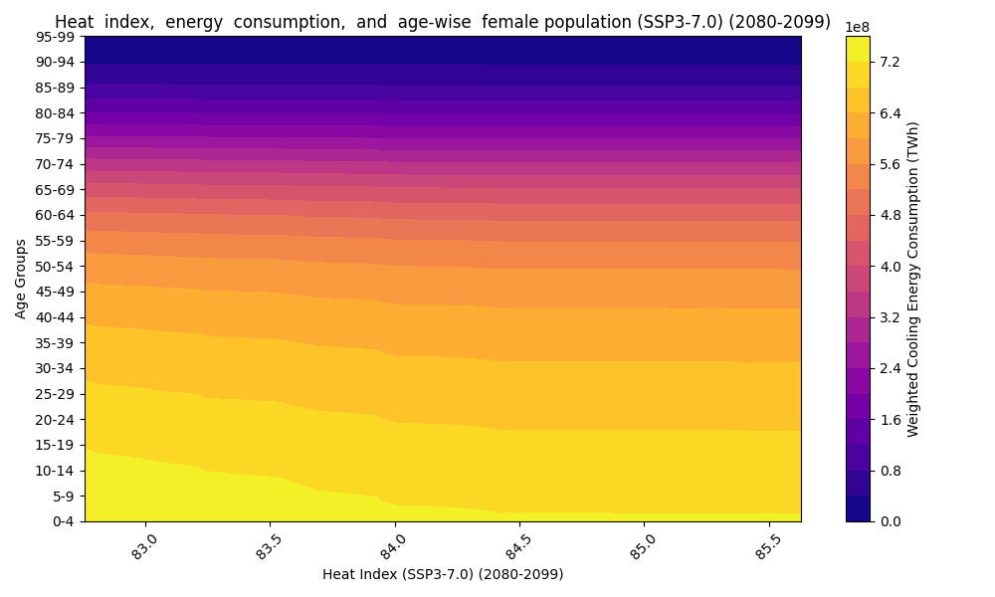
Figure 27: Females, SSP3-7.0 (2080–2099)
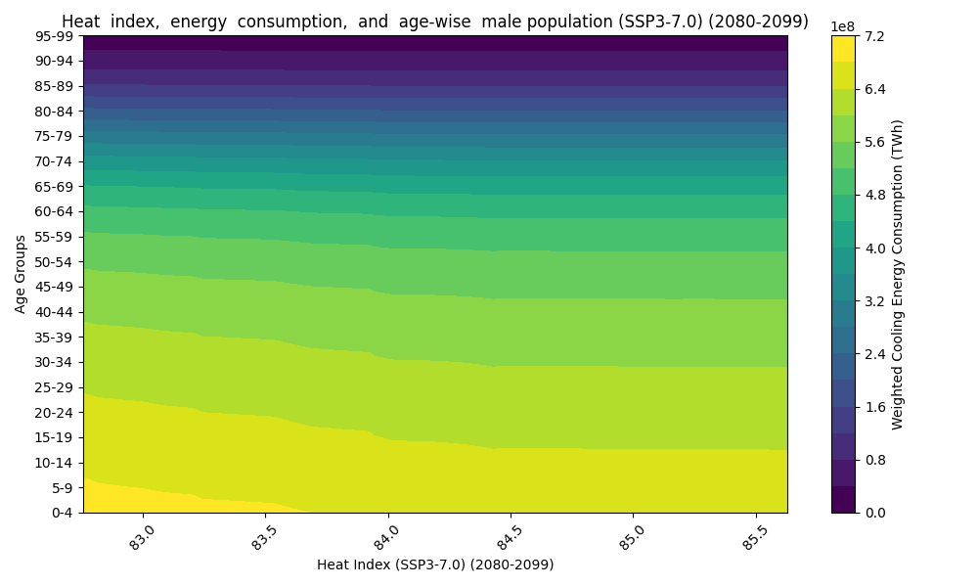
Figure 28: Females, SSP3-7.0 (2080–2099)
Figure 29: Females, SSP5-8.5 (2020–2039)
Figure 30: Males, SSP5-8.5 (2020–2039)
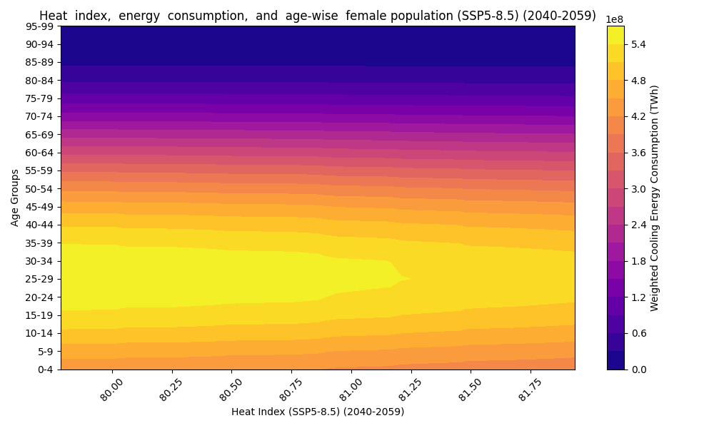
Figure 31: Females, SSP5-8.5 (2040–2059)
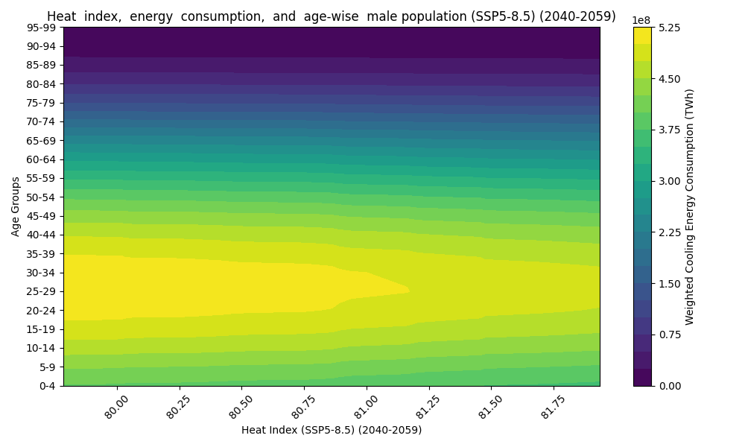
Figure 32: Males, SSP5-8.5 (2040–2059)
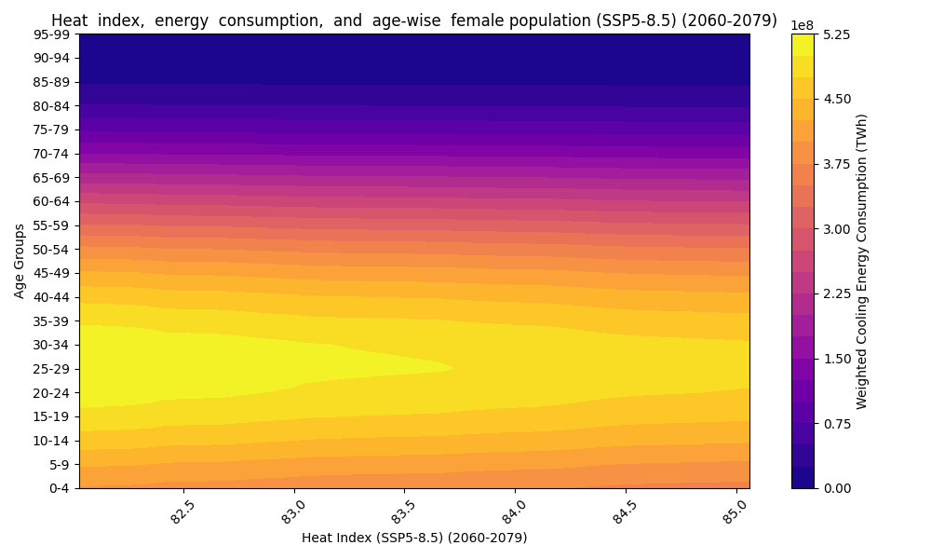
Figure 33: Females, SSP5-8.5 (2060–2079)
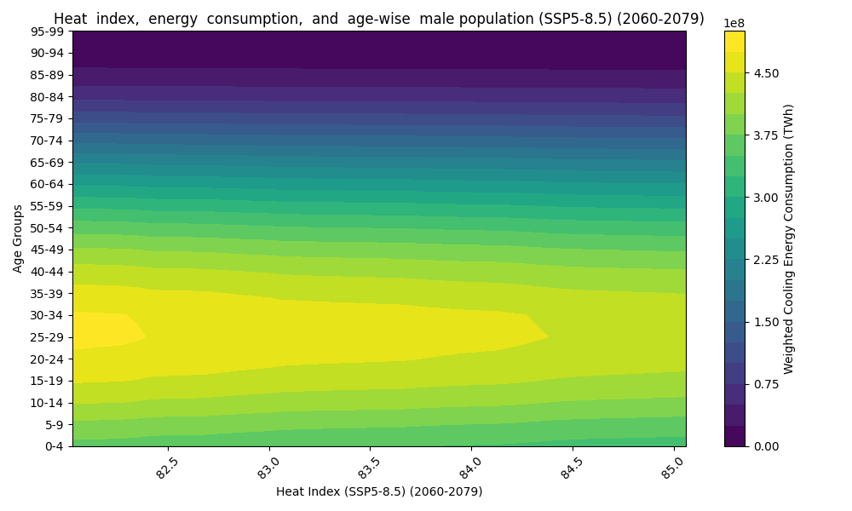
Figure 34: Males, SSP5-8.5 (2060–2079)
Figure 35: Females, SSP5-8.5 (2080–2099)
Figure 36: Males, SSP5-8.5 (2080–2099)
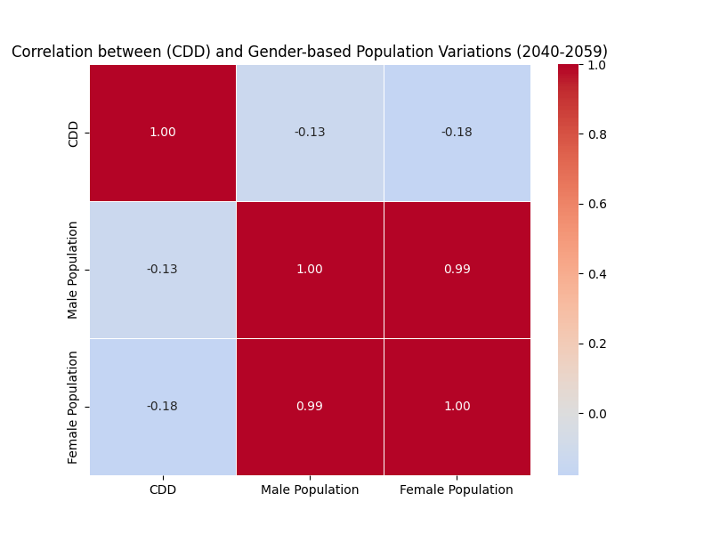

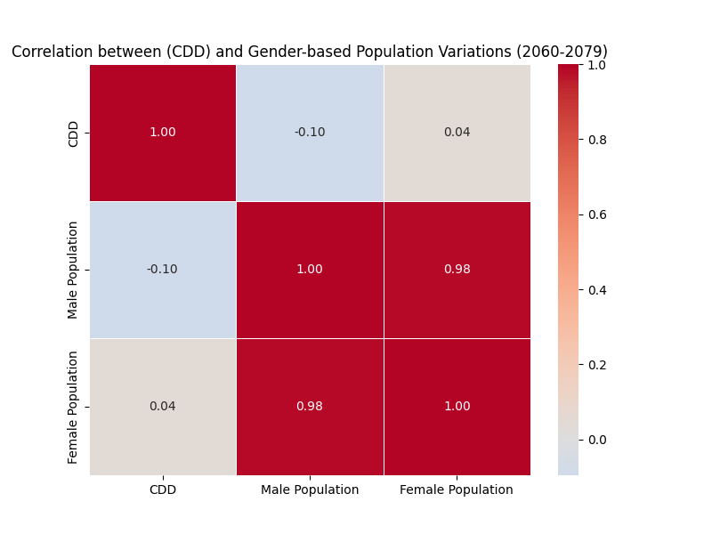
Figure 37: SSP1-1.9 (2040–2059)

Figure 38: SSP1-1.9 (2060–2079)
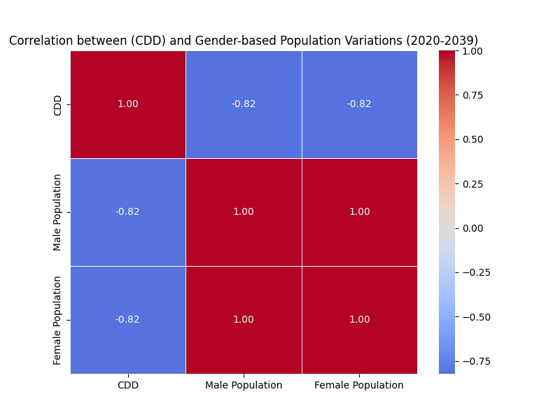

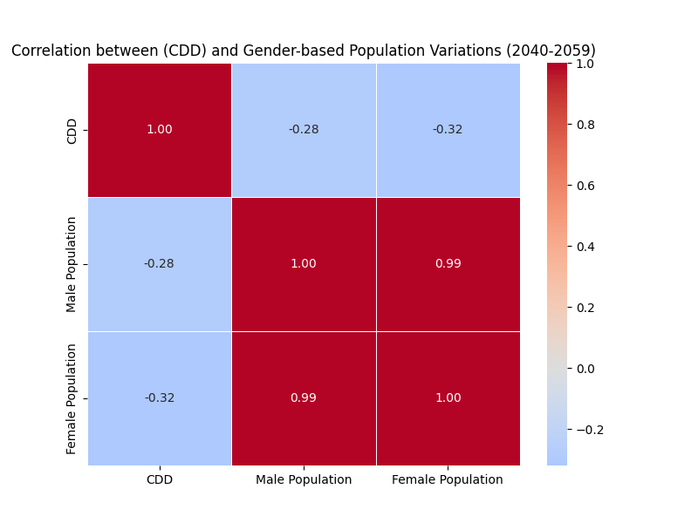
Figure 39: SSP1-2.6 (2020–2039)

Figure 40: SSP1-2.6 (2040–2059)
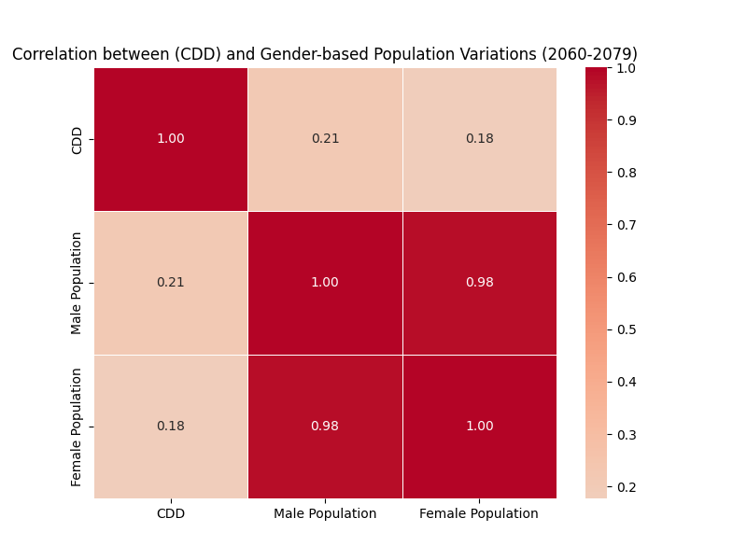

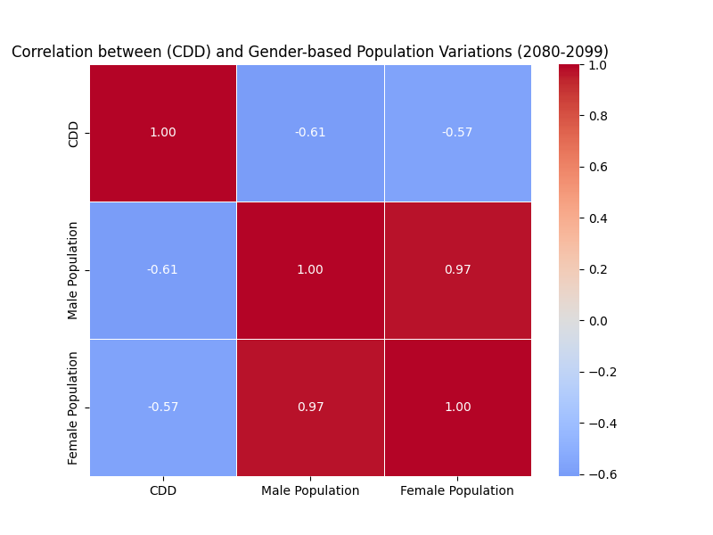
Figure 41: SSP1-2.6 (2060–2079)

Figure 42: SSP1-2.6 (2060–2079)
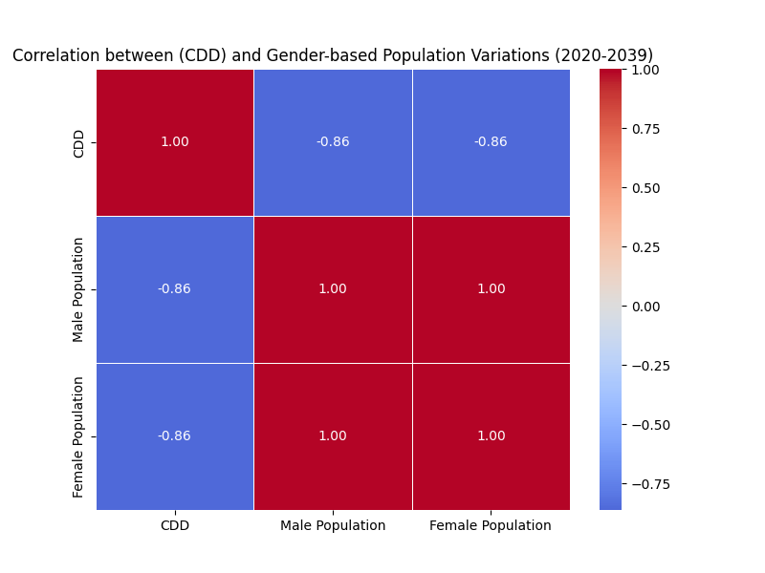

Figure 43: SSP2-4.5 (2020–2039)
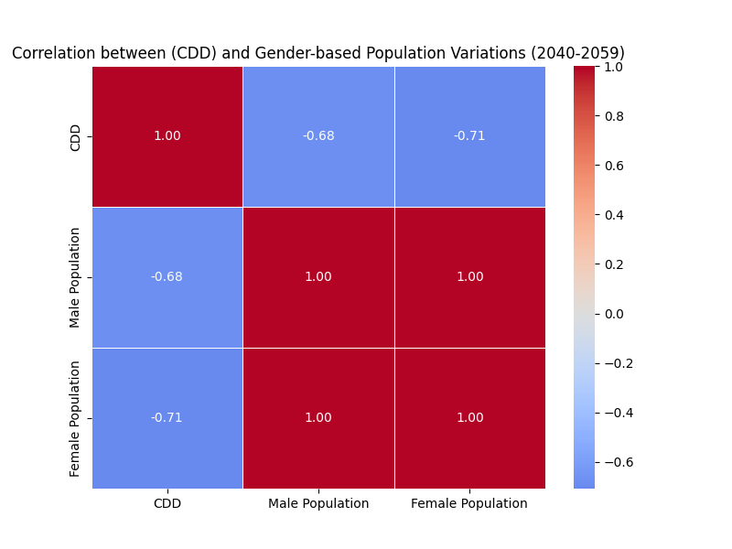

Figure 44: SSP2-4.5 (2040–2059)
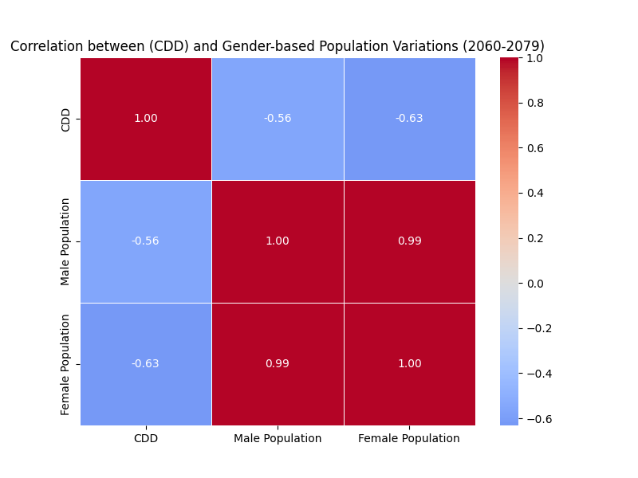

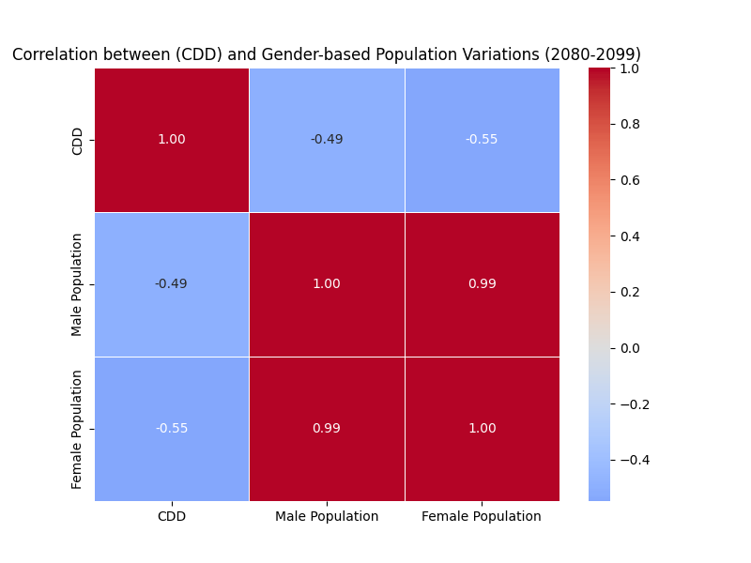
Figure 45: SSP2-4.5 (2060–2079)

Figure 46: SSP2-4.5 (2080–2099)
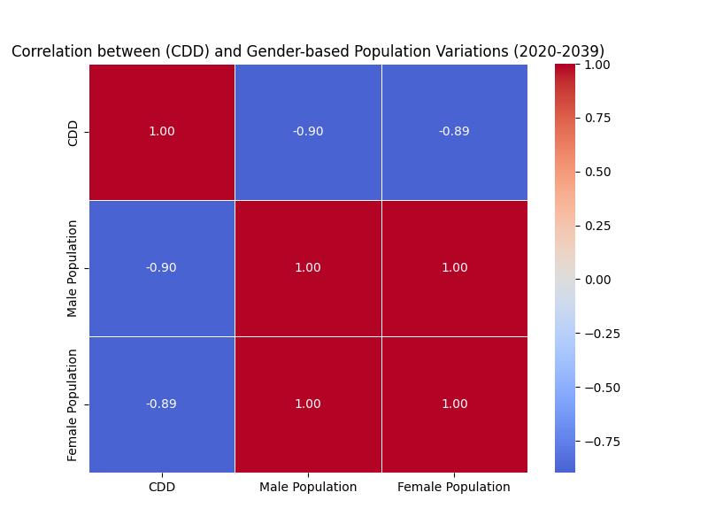

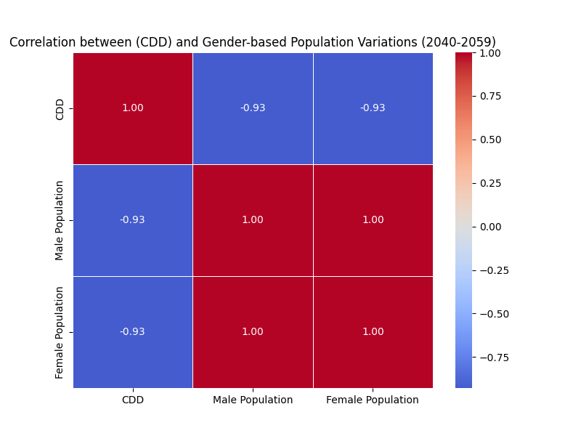
Figure 47: SSP3-7.0 (2020–2039)

Figure 48: SSP3-7.0 (2040–2059)
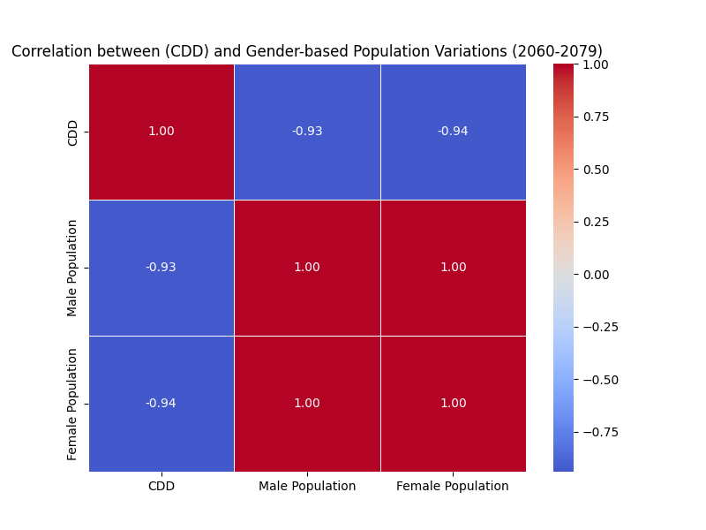

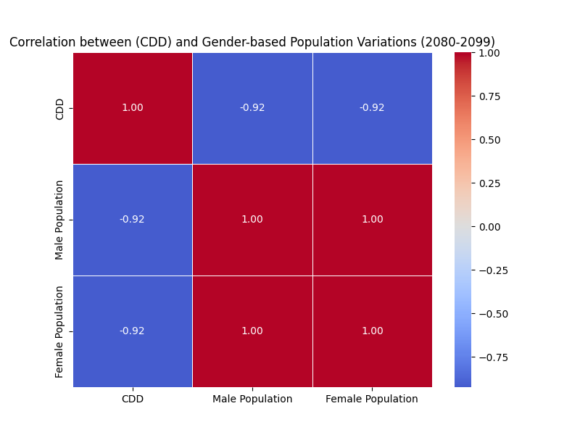
Figure 49: SSP3-7.0 (2060–2079)

Figure 50: SSP3-7.0 (2080–2099)

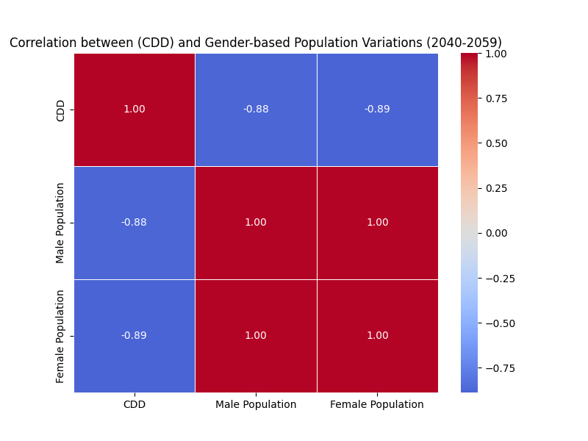

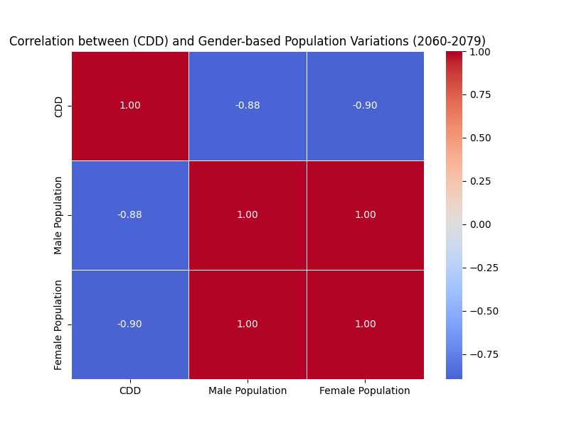
Figure 51: SSP5-8.5 (2040–2059)

Figure 52: SSP5-8.5 (2060–2079)
Declaration Regarding AI Usage
To Whom It May Concern,
I acknowledge the recent communication regarding the detection of potential AI generated content in my submission. I would like to clarify that while I may have used AI based tools to assist with proofreading or idea structuring, similar to how Grammarly is used for spelling errors. The core research, analysis, and original writing were conducted by me.
However, according to your policy and to ensure transparency, I confirm that any AI assistance did not replace the academic integrity or authorship of the work. The submission reflects my own understanding, insights, and synthesis of the subject matter.
This is the attached signed declaration as requested, and I am submitting my Second Draft with the given revisions.
Thank you for your understanding.
Best Regards,

Aanchala Bhongade
Visiting Researcher, Cambridge Collective Intelligence & Design Group
17/04/2025

